Factors affecting food production

ESSENTIAL QUESTION: How do we know that Australia is food secure?
Producing enough food to sustain the Earth's population is becoming more of a challenge. As environmental constraints keep tightening, technological innovation may be the answer to future food security.
Compare the status of food production and food security in Australia with that of developing nations. Consider some claims and evidence about food production. Investigate what can be done to feed the world of tomorrow, and how it might best be accomplished.
Environmental limitations
A productive crop can be described in terms of crop yield. This refers to the amount of product harvested for a particular area and, in countries using the metric system, it is usually measured in metric tonnes (t) per hectare (ha). Addressing factors that limit crop yield will influence a nation's ability to be food secure (dealt with in more detail in 'Feeding the future' section).
Some ideas to build upon!
TASK
In the space below, brainstorm factors that might affect crop yields. Think about basic environmental conditions such as temperature, rainfall and soil – but also consider factors such as sowing method/timing, pests, disease, farm management, fertilisers and suitability of crops.
DISCUSSION
Environmental conditions are critical in determining crop yields. This is quite evident in Africa. But… what do you know about Africa? Through discussion, try answering the following questions:
- Which African countries can you name?
Pastoralist - a grazier or land-holder raising sheep, cattle, etc. on a large scale

- What geographic regions would you divide Africa into?
- How does the African landscape vary between these regions?
- What are the climatic characteristics of these regions?
- What kinds of challenges do farmers face in Africa?
- What is the population like in those regions?
View the CLIP Ethiopa’s Nomadic Pastoralists doing it tough
- Which environmental factors are dealt with in the video? Focus on climate, access to water, soil, vegetation and animals.
- How might these factors affect crop yields?
- The video discusses ‘nomadic herding’. Find out what this is and explain the farming methods used with this form of farming.
- How are families responding to the changed environmental conditions?

DISCUSSION
Subsistence Farming – Growing
enough food to feed the family and
no more.
Refer to the World Hunger Map found here.
- Which continent in the world has the highest rate of hunger?
- What is the spatial pattern of hunger in Africa?
View the CLIP Feeding the Hungry in Timor Leste
- Discuss the environmental conditions shown in this video.
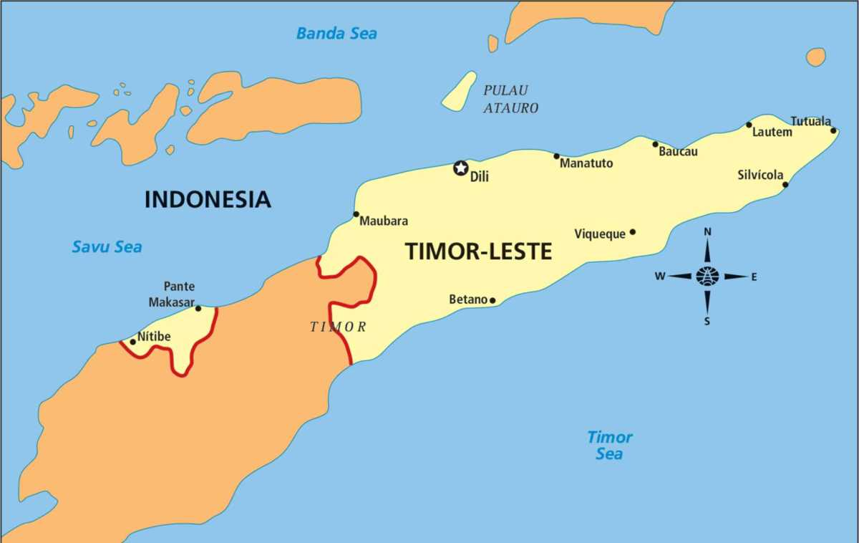
- What are the characteristics of the land in terms of temperature, rainfall, soil and animals and plants?
- Consider the small area used to grow enough food for one large family. How is the land prepared, by whom, and what farming methods are used? What advantages are there in sowing different varieties of crops at the same time? How important is it four families to grow food for the whole year rather than selling it at the market?
- How do environmental conditions limit food production in this region?
- How does Timor-Leste compare with Australia’s limits to agricultural production?
TASK
Describe how environmental factors can affect food security in different regions.
__________________________________________________________________________________________________________________________________________________________________________________________________________________________________________________________________________________________________________________________________________________________________________________________________________________________________________________________________________________________________________________________________________________________________________________________________________________________________________________________________________________________________________________________________________________________________________________________________________________________________________________________________________________________________________________________________________________________________________________________________________________________________________________________________________________________________________________________________________________________________________________________________________________________________________________________________________________________________________________________________________________________________________________________________________________________________________

Technological innovation
DISCUSSION
- If the world becomes warmer, how might farmers adapt?
- How might farmers adapt to more/less of rainfall?
- What about the effects of increased frequency of storms, cyclones and floods?
- In what ways would the response to changing conditions vary between agricultural industries? Think about wheat, sheep and dairy farmers.
- What effect might a nation's level of development and established farming practices have upon the response of their farmers to these challenging climatic conditions?
Using technology in agriculture can cost a lot of money. Machines can be used to sow seeds faster, or to pick fruit quicker. Irrigation pipes can reduce water loss into the soil and through evaporation. Water pumps can be installed to irrigate agricultural lands that are further away from a water source. Newly developed chemicals can control weeds and pests. However, not all regions in the world have access to the money that is required to implement these technological strategies to improve crop yields. Developing countries only have limited access to these technologies.
View the CLIP Winning the race to feed a growing population.
- How can plant science improve crop yields?
- In the area of ‘plant science’, what technological innovations could improve breeding and genetic modification?
View the CLIP Genetic Modification
View the CLIP Genetically Modified Organisms, Myths and Truths
- What is genetic modification?
- Glyphosate is the most used herbicide in the world. According to the video, how does Glyphosate impact on the functioning of ecosystems?
Scientists are endeavouring to create plants that are drought-resistant, salt-tolerant or more efficient users of nitrogen.

View the CLIP Feeding soils to grow hungry crops.

This clip demonstrates the importance of seed selection in determining crop yields, which in itself is a technological innovation. The seeds are those of foods already familiar to the people of the area. These seeds are grown in plots where they can be tested under local conditions, and it is this local testing that informs the selection of a particular variety of crop.

- How has seed selection improved crop yields in Timor-Leste?
- What have been the benefits of training local Timor-Leste citizens better agricultural practices?

TASK
Identify technological factors that influence crop yields?
__________________________________________________________________________________________________________________________________________________________________________________________________________________________________________________________________________________________________________________________________________________________________________________________________________________________________________________________________________________________________________________________________________________________________________________________________________________________________________________________________________________________________________________________________________________________________________________________________________________________________________________________________________________________________________________________________________________________________________________________________________________________________________________________________________________________________________________________________________________________________________________________________________________________________________________________________________________________________________________________________________________________________________________________________________________________________________
Discuss the advantages and disadvantages of technological innovation in food production.
__________________________________________________________________________________________________________________________________________________________________________________________________________________________________________________________________________________________________________________________________________________________________________________________________________________________________________________________________________________________________________________________________________________________________________________________________________________________________________________________________________________________________________________________________________________________________________________________________________________________________________________________________________________________________________________________________________________________________________________________________________________________________________________________________________________________________________________________________________________________________________________________________________________________________________________________________________________________________________________________________________________________________________________________________________________________________________

Feeding the future
Australia currently produces enough food to feed both its population and to export globally. With future environmental conditions expected to be more challenging significant innovation and development in the agricultural sector Will be important if Australians are to enjoy a high quality of living.
View this CLIP Please, Sir, Can I have some more?
DISCUSSION
- Based on the statistical data provided in the video, is Australia a net importer or exporter of food? Why might this be the case?
- What do you think is meant by the term ‘resource use efficiency’?
- What role does the video suggest that Australian farmers have to play in sustainable food production in the future?
- Another aspect of resources is efficiency is a reduction in waste. What are some examples of food wastage that occurs in your home, at school, in the community and in our supermarkets?

Food security and sustainability
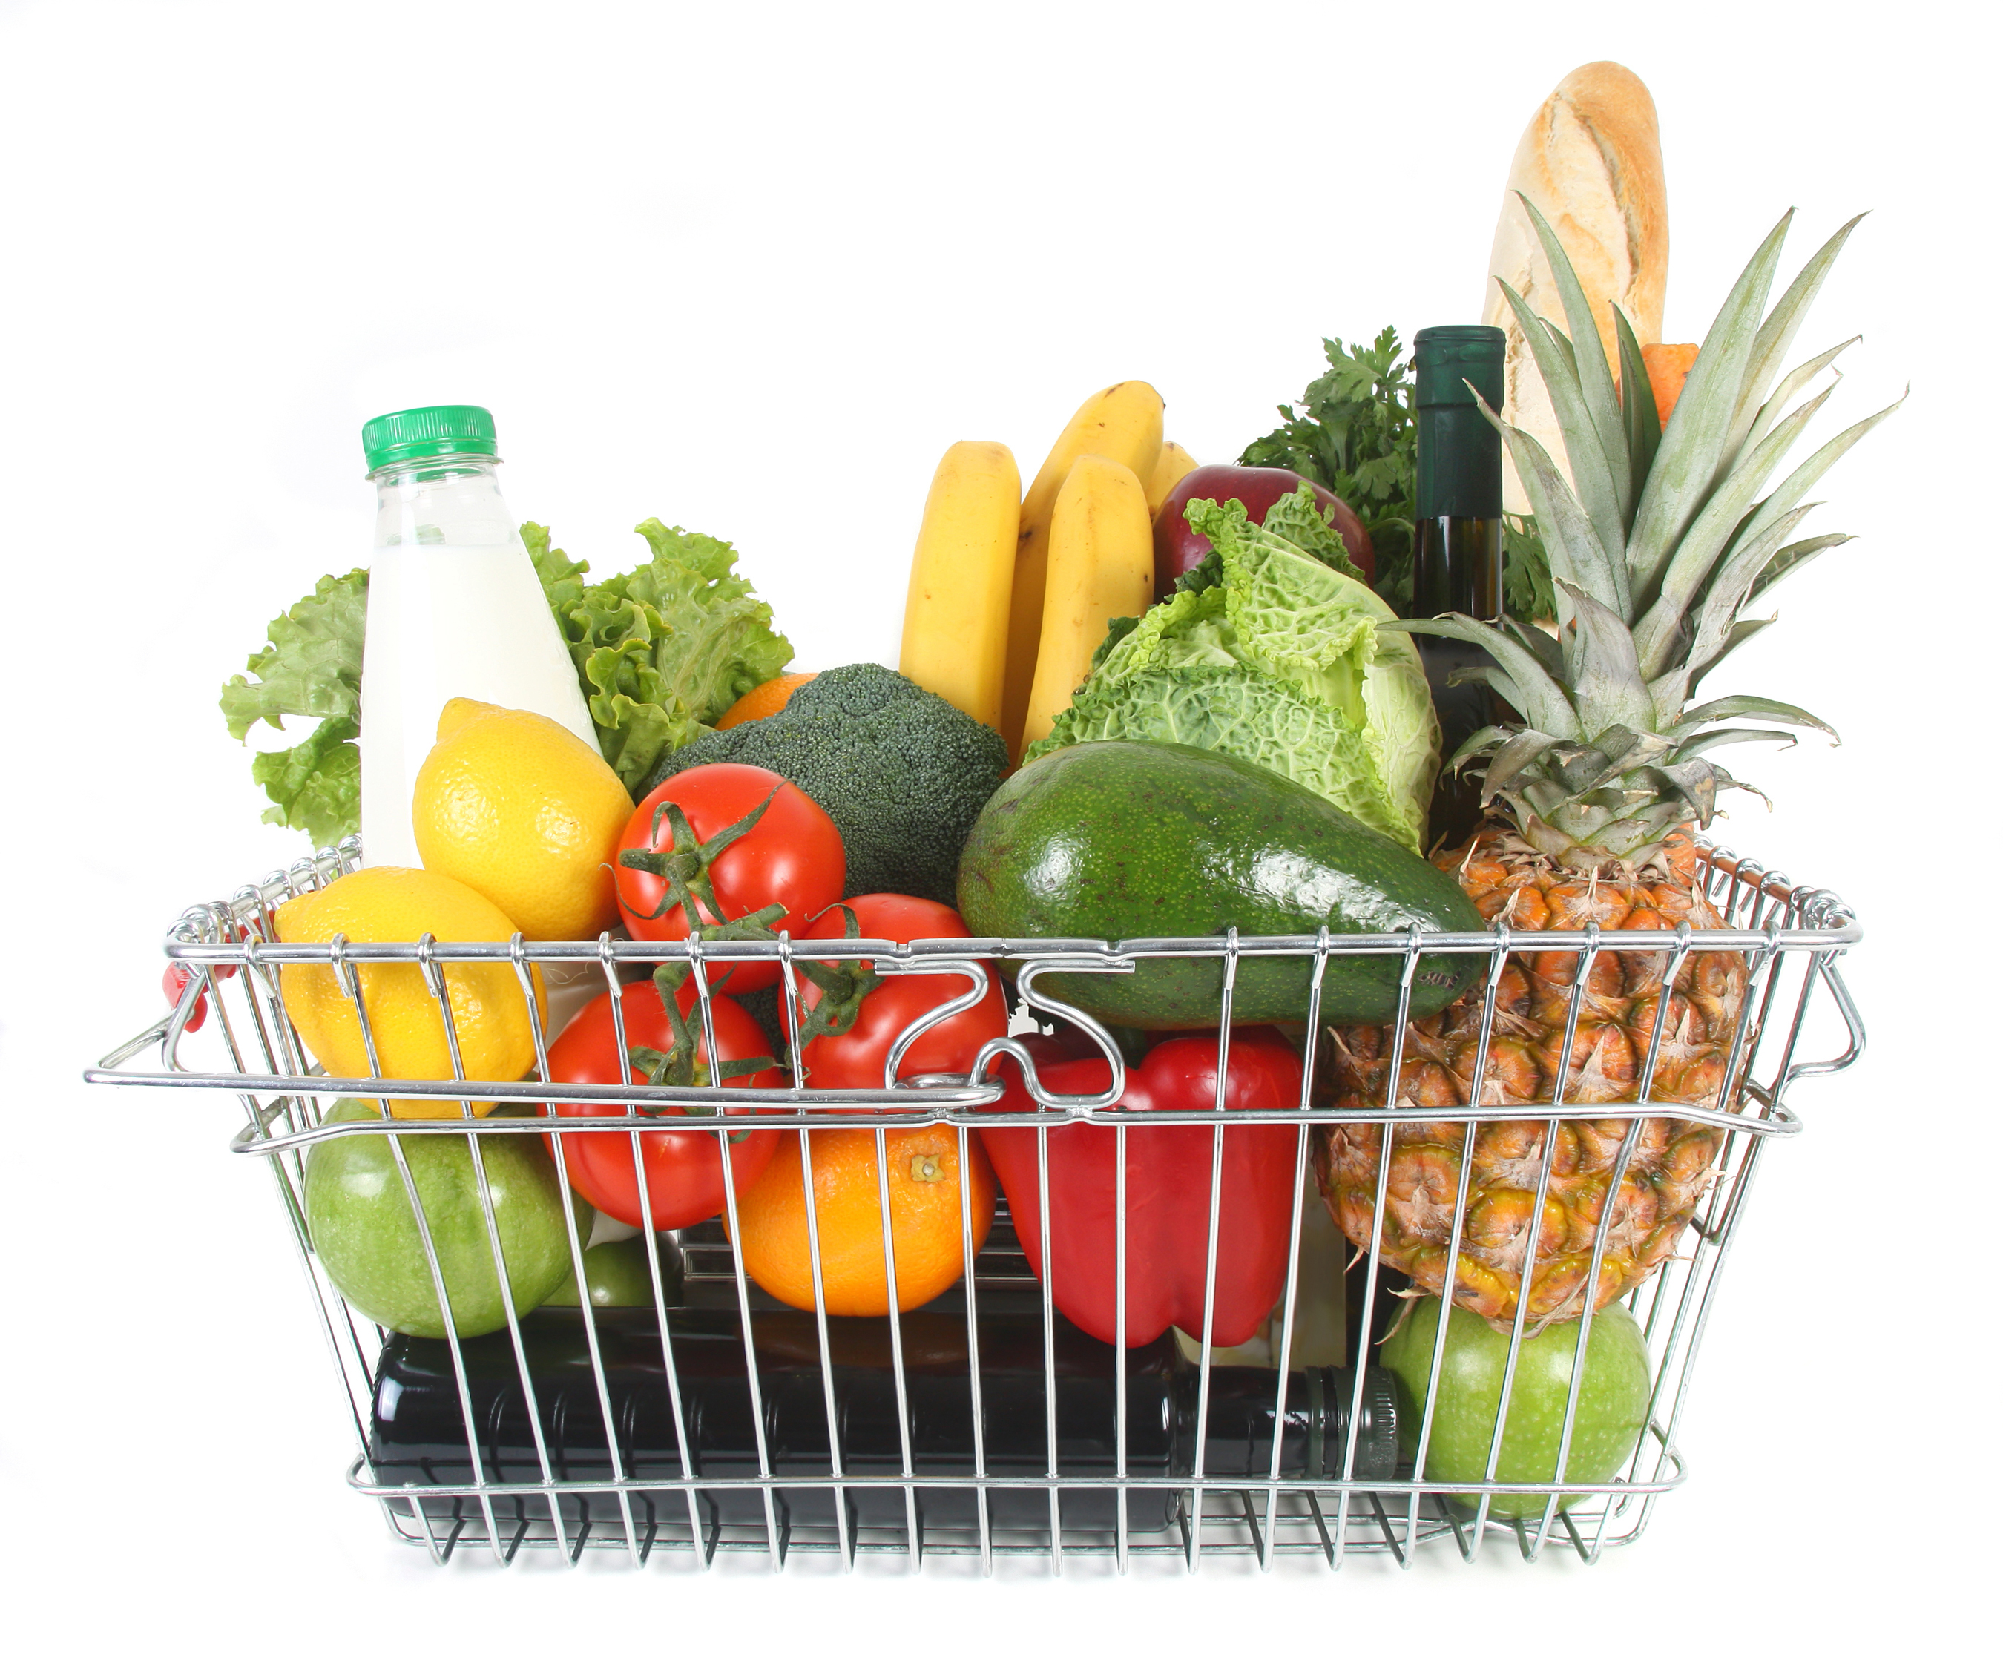
Australia is a nation that currently enjoys food security. But can our food production capabilities keep pace with the projected rate of environmental and social change? Achieving food security is about insuring that our nation will have enough food to support its population in the future.
DISCUSSION
- What do you think are Australia’s top five food exports?
- What do you think are Australia’s top five food imports?
View this CLIP Food Security in Australia.

TASK
Outline the challenges of food security for Australia.

__________________________________________________________________________________________________________________________________________________________________________________________________________________________________________________________________________________________________________________________________________________________________________________________________________________________________________________________________________________________________________________________________________________________________________________________________________________________________________________________________________________________________________________________________________________________________________________________________________________________________________________________________________________________________________________________________________________________________________________________________________________________________________________________________________________________________________________________________________________________________________________________________________________________________________________________________________________________________________________________________________________________________________________________________________________________________________________________________________________________________________________________________________________________________________________________________________________________________________________________________________________________________________________________________________________________________________________________________________________________________________________________________________________________________________________________________________________________________________________________________________________________________________________________________________________________________________________________________________________________________________________________________________________________________________________________________

http://splash.abc.net.au/home#!/media/526545/
http://documents.wfp.org/stellent/groups/public/documents/communications/wfp275057.pdf
http://splash.abc.net.au/home#!/media/524345/
http://splash.abc.net.au/home#!/media/524411/
https://www.youtube.com/watch?v=HZmZ161njr8
https://www.youtube.com/watch?v=M_ztZGbLEJ0
http://splash.abc.net.au/home#!/media/524367/
http://splash.abc.net.au/home#!/media/524389/
http://splash.abc.net.au/home#!/media/526919/

