Interconnections Workbook
This workbook belongs to: ___________________________________________

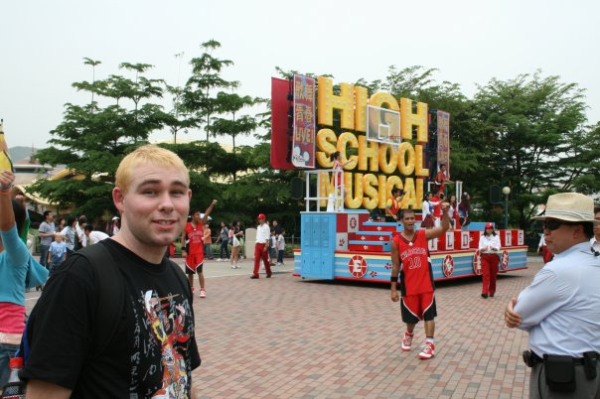
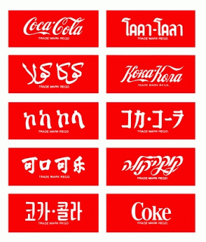
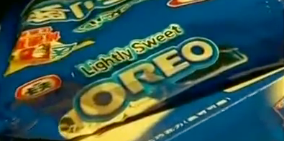

GLOBALISATION
For this topic it is important that you understand the process of globalisation.
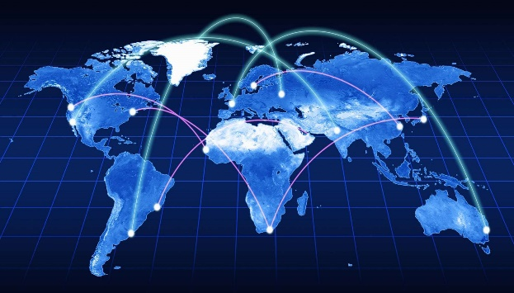
Globalisation is the process of the world and its people becoming increasingly more interconnected. This means that there are new pathways for goods, ideas, money, people and services to flow around the world. They can move easily from one point in the world to another along transport and communication lines which can now join people and places almost instantly.
ACTIVITY: Google “Globalisation” and see how many results the search achieves and how long it took.
Number of results: Time:
Do you think this much information was at the finger tips of people 50 years ago? 100, or 500 years ago?
It is due to advancements in transport and communications technologies that we can now connect and share information and goods throughout the world.
A good example of the changes in transport might be travel times. From England to Australia 200 years ago it would have taken almost a year on a sailing boat. Today the same distance can be covered in around 24 hours.
This has some very strong positive results, as well as some negative ones. These will be explored in this topic by looking at different interconnections in the world today and how they apply to how the world works, including where you fit in and the role you can play.
ACTIVITY: Think of some examples of transport and communication technologies and the positive and negative effects they have on your life.
 | Positive effects | Negative effects
Transport examples
Communication examples

GLOBALISE ME!
Many of your clothes, electronics, media and fashion come from another country. This demonstrates that people, ideas, goods, services and money are moving around our world by processes such as migration and trade.
ACTIVITY: create a document which show how globalised you are.
- Create a word document called “globalised (your name)”
- Find an outline picture of a person and paste it into your document.
- Make notes using text boxes to show how you are connected to other countries. Find photographs on the internet to show this.
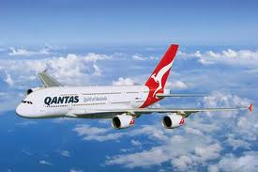
Example:
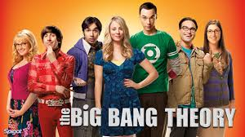
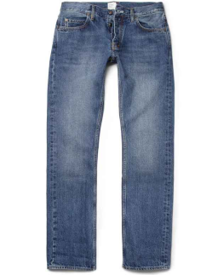
Flown to Hong Kong, Turkey, Greece and Italy
Wear jeans made in China but designed in USA

Watch American TV shows e.g. big bang

Do as many as you can think of!

Glossary
Assimilation | A situation whereby one group slowly takes on the cultural norms of another e.g. immigrants to their host nation.
Commodity | Any raw material that can be exchanged e.g. oil, wheat etc.
Consumer | A person who buys goods or services.
Fossil fuel | Energy derived from the remains of organisms e.g. coal, oil, gas etc.
Free trade | An agreement which allows trade between nations free of any border restrictions.
Globalisation | A process where trade, migration and communication that used to be on a local or national scale move to include the whole world. It is occurring due to advancements in technology and removal of barriers (political) between countries.
Goods and services | Products that can be sold. Goods refers to physical, tangible products; services to intangible ones such as shops
Gross Domestic Product (GDP) | The total economic value of goods and services produced by a nation.
Gross National Income (GNI) | The total income of a nation including those sources brought in from overseas.
Information technology | The range of electronic equipment used in modern communications.
Interdependence | A relationship of mutual need between regions or nations.
Linkages | Flows of inputs and outputs, usually for companies but could also be settlements, nations etc.
Monopoly | Where one company or person is the sole supplier of a good or service.
Non-renewable resource | Fossil fuels (coal and oil) that cannot be replaced.
Quota | A set number e.g. export quota.
Renewable resource | A resource for which there is no practicable limits because it is constantly replaced e.g. solar power.
Tariff | An amount of money paid to import specific goods.
Tourism | An activity, undertaken voluntarily for pleasure, that involves staying away overnight.
Trade | The sale of goods and services.
Trans National Corporation (TNC) | Global companies with headquarters in more than one country.
Unemployment | A situation where a person does not have employment.

Check your understanding
Multiple Choice – Circle the most correct answer
- Trade is:
  - The sale of goods and services
  - A number of goods sold
  - A recreational activity

- Information technology is:
  - Ancient communication equipment
  - Modern communication equipment

- A monopoly is when:
  - Many people play a game about property
  - Many people or businesses supply a good or service
  - One person or business supplies a good or service

- Interdependence is when:
  - Two or more countries rely on each other for trade
  - Three countries trade with each other
  - One country does not rely on others for trade

- A commodity is:
  - Material that can be traded
  - Material that cannot be traded

- Someone who buys goods or services is:
  - A monopoly
  - A tariff
  - A consumer

- Trade and migration on a global scale has resulted due to:
  - Globalisation
  - Assimilation
  - Unemployment
True or False – circle the Correct answer
- Unemployment is where a person has a full-time job, like all the time. True/False

- A transnational corporation is a company that operates in more than one country. True/False

- GDP is the total monetary value of goods and services produced in a country. True/False

- A fossil fuel is a type of petrol dinosaurs used to get around. True/False

- Assimilation is where a migrant group takes on the language and culture of their new home nation. True/False

- Tourism is the forced movement of people on a temporary basis to a country to enjoy fun activities on a holiday. True/False

- Globalisation is a process where the world is becoming more interconnected due to the increased trade, migration and communication linkages from the removal of barriers between countries such as political barriers and even geographic ones e.g. oceans, which are now easily overcome by ships and planes. Globalisation is probably the most important idea which underpins this whole topic (interconnections), so you should become super familiar with it. True/False

Personal connections
- What influences your travel, recreation and culture and what effects do they have?
Key Questions:
- How are patterns of travel and recreation influenced?
- How do travel, recreation and culture affect places into the future?
- What are the ongoing effects of travel and large scale tourism on the sustainability of a location?

Illustrative example: Tourism
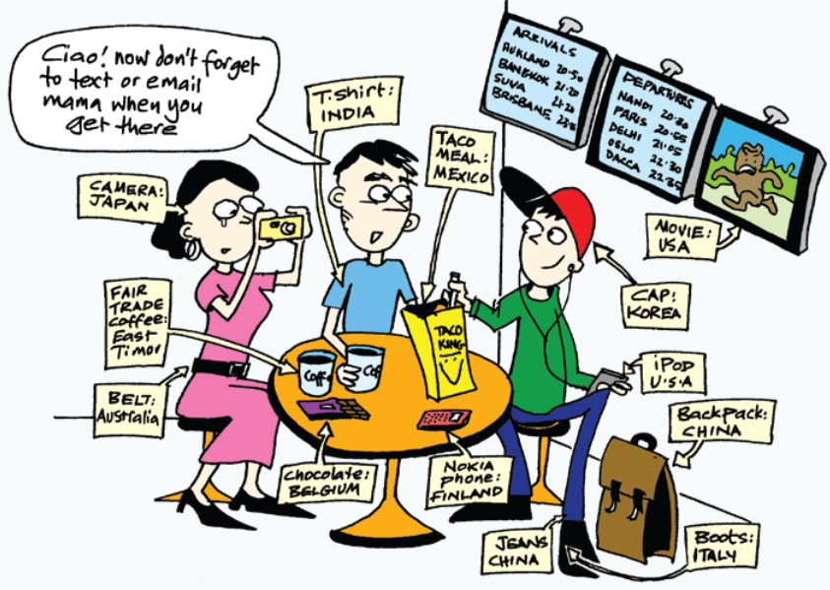

We live in a world wear/where we are connected with people from many different countries/countrys. Even though/thow we live in one country, we also live in one world – and we are connected to other countries in a whole range of ways - the __________________ we eat, the __________________ we wear, the sports we play, the __________________ we watch and the __________________ we listen to. People __________________ other countries for holidays and work. Others ________________ to different countries to live. The internet and mobile fones/phones mean that we can __________________ with people all over the world.
Globalisation is the term used to describe the way people in different countries are becoming more and more interconnected.

- Name two sources of technology found in the image
________________________________________________________________
- Which continent do most of the items come from?
_______________________________________________________________
- Why do you think this continent makes the most amount of items?

Tourism in Bali
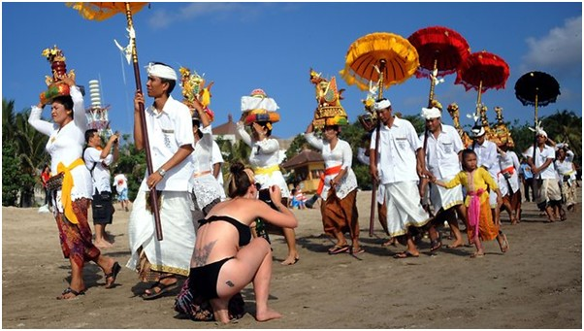
ACTIVITY: complete the See, Think, Wonder table based on the image above.
What do you see? | What do you think is happening? | What do you want to wonder or want to ask questions about?
In the space below think of a reason you would like to visit Bali
_______________________________________________________________________________________
Here are some examples that consistently makes the list of the top reasons most tourists visit Bali. Turn to the person next to you and try and describe the items on the list, without using those words.
For example: Tourists want to visit Bali to eat the local foods, would be a description of Cuisine
- Beaches
- Temples
- Culture
- Weather
- Value for money

Where Is Bali?
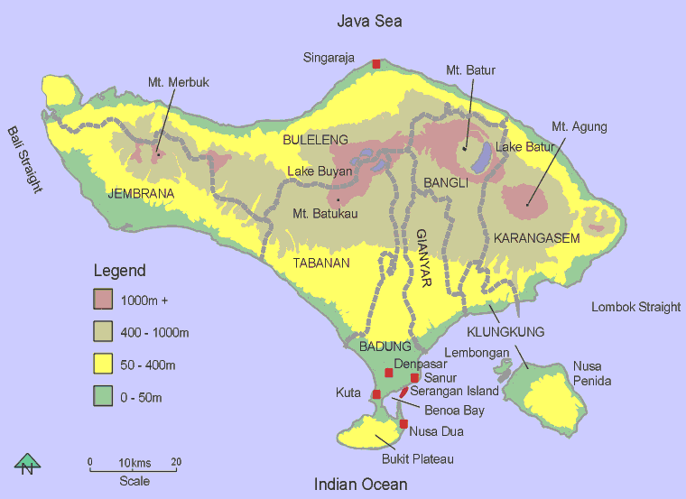
ACTIVITY: the images below to respond to the questions about Bali and its location.
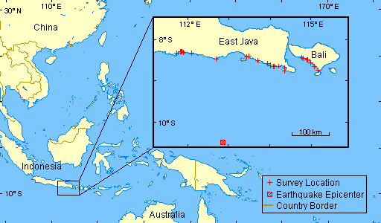
- What country does the Island of Bali belong to?

- What is the northern most town in Bali?

- What ocean does Bali sit in?

- What is an approximate latitude and longitude for Bali?
- What is the distance and direction of Kuta from Mt Agung?
- What body of water separates Bali from Java?
- The major towns and cities in Bali are located in the North/South

ACTIVITY: Create a line graph using the statistics on foreign visitor numbers to Bali.
Year | Number of foreign visitors (nearest 1000)
1965 | 42,000
1975 | 215,000
1985 | 1,450,000
1995 | 4,680,000
2005 | 5,102,000

SKILL: Semi-logarithmic graphs
Semi-log graphs are used when you have a large set of data to graph. In this case we are staring at 42,000 and graphing data all the way up to 5,000,000 and more. TO make sure the data fits on the graph space we are going to have to be a but creative with the vertical scale.
Can you see how it is not regular or each value does not always increase by the same value? This is done so that we can include all the data on one graph space. Imagine how tall the graph would need to be if the vertical scale went up by 10,000. It would probably have to be taller than your classroom.
10,000,000

5,000,000

1,000,000

500,000

100,000

50,000

10,000
2005
1995
1985
1975
1965

What Are The Effects Of Tourism In Bali?
There are three broad areas geographers usually investigate when looking at impacts:
- Economic – usually to do with money, income and costs
- Social – usually to do with people, health, education and culture
- Environmental – usually to do with the state of the natural environment
Effects on local economy
Tourism provides work, profits for local businesses, increasing formal employment in tourism. It has also increased rates of internal migration as people move from mainland Java to Bali for employment opportunities. This has led to the migrant workforce becoming wealthier and local Balinese, who did not take on the tourism industry at the same pace, in relative poverty.

SKILL: writing an explanation.
In Geography you are expected to connect ideas together and show how they are related. Explanation writing is a way to do this. Simply, an explanation could be two ideas (a cause and effect) connected with a linking phrase e.g. The sun rose which led to the rooster crowing.

In this example the cause was the sun rising. It had an effect of the rooster crowing. The linking phrase that joined the ideas was “which led to”. It can be that simple, you just have to get the order right.

Another way to think about writing an explanation is like writing a narrative. In a story you will naturally have events in a logical order which are connected by words. You wouldn’t say in a story “John was at home. John was at the shops.” You would show the journey to connect the information e.g. “John was at home and he took the bus to get to the shops”.

Some other examples of linking phrases might be:
Resulted in | Led to | Had the effect of | Will cause
Caused | Initiated | Ended in | Will lead to

ACTIVITY: using the information about the economic effects on tourism in Bali place the cause, effect and linking phrase into the chain below.
Effect
Cause
Linking phrase

Effects on community and culture
When visitors come to new location the local population will often alter or change things to make life easier for the tourists. An example might be having signs in the local language and in English (if that is a language that most tourists speak). This means more tourists are likely to visit in the future once they spread the word of how easy it was to communicate or get around.
The problem can be that there is too much lost from the local culture as they change the local culture to suit the tourists. In Bali this is linked to language and cultural aspects like religion. In Bali the learning of Bahasa Indonesia (the Indonesian language) has become mandatory in the school environment and is taught from primary school. In addition, the rapid growth of the tourism industry has made the use of English significant in Bali. Some places people will refuse to speak Bahasa Indonesia or English due to a fear of losing Bahasa Bali (the Balinese language).
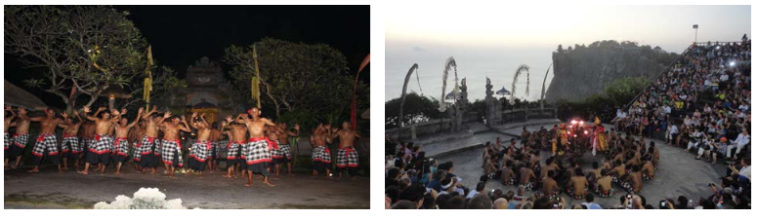
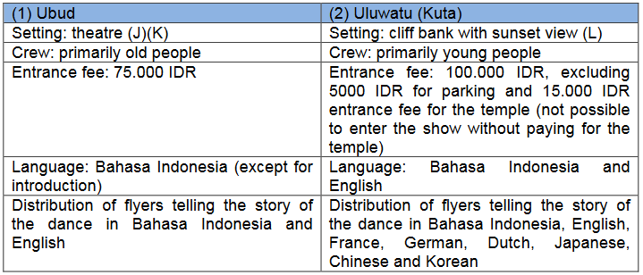
Here is an example of one tourist experienced when going to the theatre in two different places in Bali
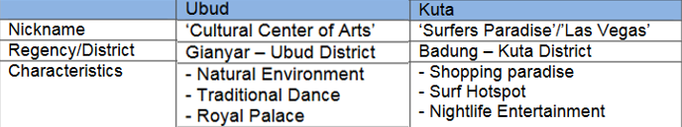
Effects on environment
ACTIVITY: wathc the video – Tourism effects in Bali, and make some notes on the issues
http://education.abc.net.au/home#!/media/524631/bali-tourism-and-development
_______________________________________________________________________________________
_______________________________________________________________________________________
_______________________________________________________________________________________
_______________________________________________________________________________________
_______________________________________________________________________________________
_______________________________________________________________________________________

ACTIVITY: create a cause and effect chain of the issues related to tourism in Bali – you may choose to focus on environmental effects of all the types of effects.
Issue
Caused by
in (location)
Will lead to (effect)
Which will have these
positive outcomes
Which will have these
negative outcomes
Overall is there a positive or negative affect of the issue?

Technology
- What role do transportation and communication technologies play in connecting people information and services around the world?
Key Questions:
- How does transportation connect people to different places?
- How does communication technology increase connections of people to services, information and people in other places around the world?
- What are the ongoing effects of increased connectivity on people and places?

Technology advancements have seen a reduction in physical and cultural barriers:
- Transport technology – has meant that distances and physical barriers e.g. oceans and mountains are no longer a problem. 300 years ago where it may have taken 8 months to sail from Sydney to London is unrecognisable as it only takes 24 hours by plane today.
- Communication technology has rapidly advanced especially with the internet. Communication on a global scale is instantaneous with email and text messages being sent in seconds.

ACTIVITY: Watch the video – Teens react to 90s internet
https://www.youtube.com/watch?v=d0mg9DxvfZE
ACTIVITY: Translate the following into another language:
“Hello, my name is __________. I am from Australia and study Geography.”
How long did it take to translate this into another language?
If you had a pen pal in Sweden, who only spoke Swedish, and were sending them this message, do you feel like there are any barriers to communicate with them?

ACTIVITY: Positives and Negatives about increased connectivity around the world
Positives | Negatives

ACTIVITY: Create a list of questions you would want to ask someone who grew up without the internet.

Illustrative Example: Culture – Media and languages
Globalisation example - languages
ACTIVITY: Try and translate this personal introduction into English and match each phrase with one of the images. See how well you do without using technology.
HINT: Saya is a personal pronoun which could stand for I, Me or My.

- Selamat Pagi.

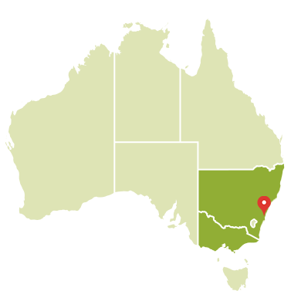
- Nama saya Pak Proctor.

- Saya tinggal di Sydney.

- Saya bekerja sabagai guru geography di Picnic Point.

Did you guess which language it was?
Did you find it difficult to translate the phrases on your own? What helped?

Have a go at translating these words from the same language (HINT: c has a ch sound):
apel coklat komputer
avocad kriket musik
bola basket telepon

Why do you think these words were easier to translate?

When a language like this one, Indonesian, is very young, it will borrow words from other languages which leads to words being very familiar.
ACTIVITY: Try writing an introduction for yourself in Indonesian.

The cultural impacts of globalisation
Cultural integration is a process where people from different cultures share ideas, language, foods, and beliefs. In many ways this is a positive process, where everyone benefits from all the positive aspects of other cultures. For example, Australian people now regularly eat Chinese food and Pizza as part of their diet.
For Indigenous people it may not always be positive. Traditional foods and languages are lost when people give them up or are forced to accept new cultural norms. Such as pineapple on pizza.
The Simpsons case study
Video – ABC news report (low quality): https://www.youtube.com/watch?v=L7Eyyz-kGzc
In the Middle East in countries like Iraq the popular Western show ‘The Simpsons’ is being aired on TV for the first time. The show has gone through some changes to suit the local audience; it is now called Al Shamshoon, Homer is now called Omar and Bart is now Bodr.
These changes are called adaptations and are used to make the show appeal to the Arabic market. Alcohol is not drunk by Muslim people so it appears on the show as soda. It is often cheaper to make small changes than to create a whole new show and the changes mean that this Western show will not offend Arabic audiences.

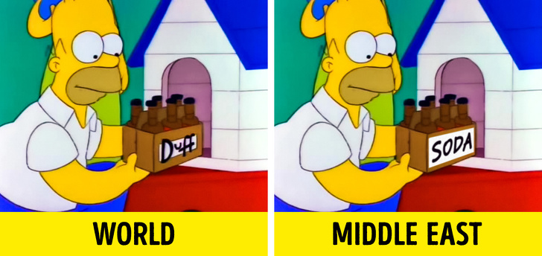

Cultural Erosion and the threat of Homogenised Landscapes
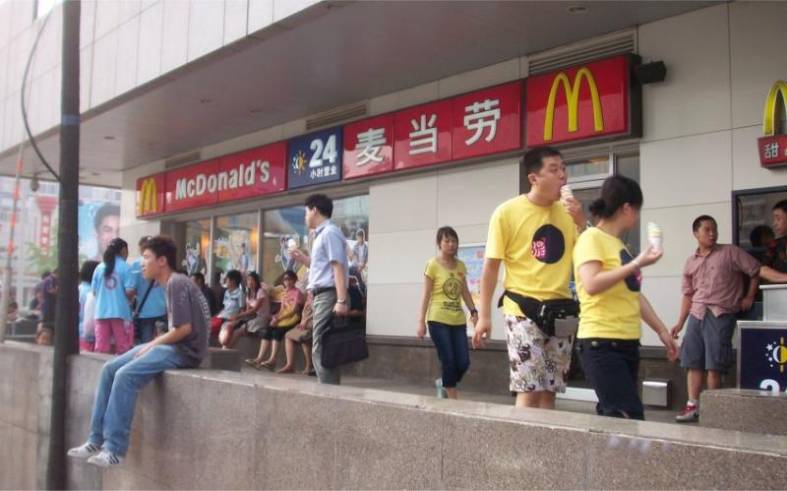
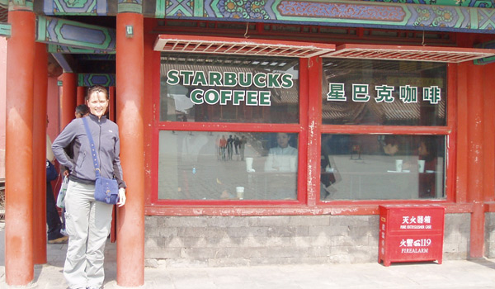
Cultural erosion is a term used to describe the loss of cultural diversity that is occurring in many places. This is due to new ideas, new products and new ways of doing things that enter a culture and replace the existing or traditional ways. Examples include the spread of food and drink, clothing styles, music, movies and language from more dominant cultures, particularly the United States.
ACTVITIY:
- Describe some of the areas of your life (from the list above) that are influenced by the United States.
One impact of cultural erosion is the loss of languages. More than 40% of the world’s 7,000 languages are considered to be endangered and more than 200 have become extinct in the last few decades.
ACTIVITY:
- Predict how a language can become endangered or extinct.
- What are the likely effects for a person who doesn’t speak one of the dominant languages in a community/country?
- What do you think happened to Aboriginal and Torres Strait Islander language and culture after European peoples colonised Australia?
Video – Languages matter: https://www.youtube.com/watch?v=Q-XozG0RSCo
Possible solution:
Languages can be lost when people stop using them. Reasons for this can include: the dominance of only one or a few languages in education, politics and trade, or even when speakers of a language die.
People who don’t speak the dominant language are at a disadvantage and may include not benefitting from commerce/trade easily and misunderstanding of their intellect or abilities due to miscommunication.
After European colonisation of Australia until today there were government policies that promoted English speaking and this meant of the 500 or so different languages spoken before colonisation, most were lost, so that today only around 40 are alive.

Media Networks
US films are shown in more than 150 countries worldwide.
ACTIVITY: respond to the following questions
When was the last time you saw a film that wasn’t made by an American company?
Have you ever even seen an Australian movie?
What effect do you think our US saturated media might have on your identity?
THINK
- What is the number to call when you need the police?
- How do you spell the abbreviated form of mother?
- What colour are cups at parties?
- Do you sometimes say things with an accent that is American?

Did you know that 90% of all media is owned by just 6 companies?
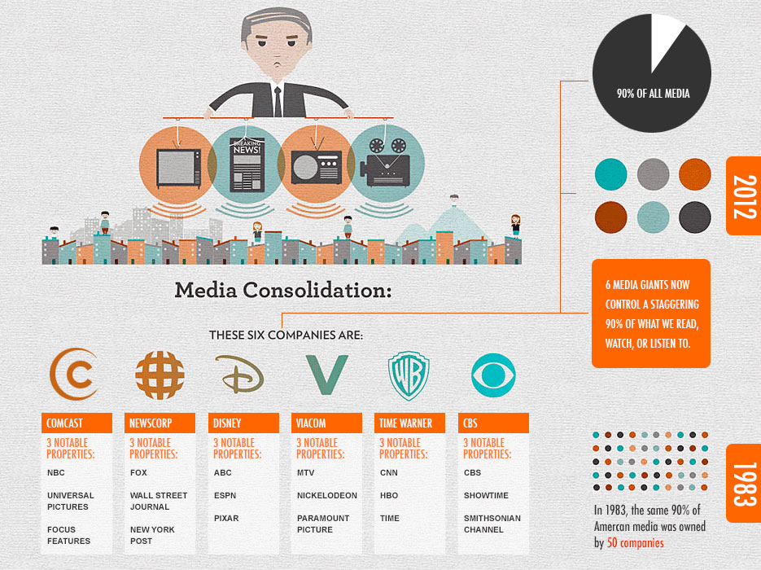
What is one solution? In Australia we have media content laws which protect our Australian culture and ensure that at least 30% of what you see on Australian TV is Australian produced content. This means it has a significant number of actors, writers and other people working on the production. The news is counted in this figure as well. Do you think this is good enough?

Trade
- What role does trade play in connecting people to goods and services across the world?
Key Questions:
- What trade linkages are there within Australia?
- How are countries connected to each other through trade links?
- Why do different countries specialise in particular trade roles and where are these shown?

ACTIVITY: Watch the video on why we trade: https://www.youtube.com/watch?v=-IW8ZzY3xt8
_______________________________________________________________________________________
_______________________________________________________________________________________
_______________________________________________________________________________________
_______________________________________________________________________________________
_______________________________________________________________________________________
_______________________________________________________________________________________

ACTIVITY: What role does regional Australia play in trading within our nation?
_______________________________________________________________________________________
_______________________________________________________________________________________
_______________________________________________________________________________________
_______________________________________________________________________________________
_______________________________________________________________________________________

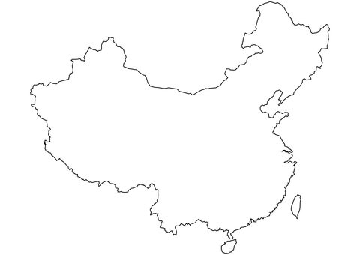
ACTIVITY: China is a strong trading partner with Australia. Research the types of goods and services we trade with each other and write this on the countries below.

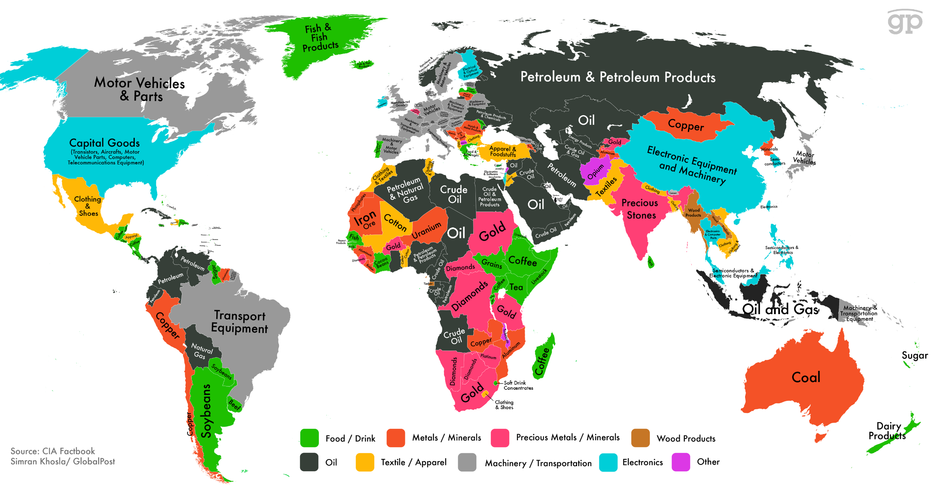
This map shows major exports from each country around the world.
How does this help explain the need for trade connections between countries?
Illustrative example: Global Brands
ACTIVITY: Complete the crossword below.
Global Brands Crossword
 |  | ^{1.} |  |  | ^{2.}
 | ^{3.}
 |  |  |  |  |  |  | ^{4.} |  |  | ^{5.}
^{6.}
 |  |  |  | ^{7.} |  |  |  |  |  |  |  | ^{8.}
 |  |  |  |  |  |  |  |  |  |  | ^{9.} |  |  |  | ^{10.}
 |  |  |  | ^{11.} | ^{12.}
 |  |  |  |  |  |  |  |  |  |  | ^{13.}
 |  |  |  |  |  |  | ^{14.} |  |  | ^{15.}
ACROSS  3. Company famous for producing mice and princesses (D)  6. North only – not South, East or West (O)  7. First you twist it, then lick, then dunk (O)  9. Nordic phones (N)  11. Swedish furniture (I)  13. Often hunted, but also an American TV network (F)  14. Underground train station that you eat (S) |  |  |  |  |  |  |  | DOWN  1. You make bird noises on this – with limited characters (T)  2. Discovered on YouTube baby (B)  4. Golden arches (M)  5. Just do it (N)  8. Japanese car brand (T)  10. Edible brand name for an inedible product (A)  12. Birds cooked in an American state (K)  15. British ABC (B)
Did you manage to get all the clues?
Do you think someone your age in a foreign country would be able to guess all of these? Why/Why not?

ACTIVITY: study the diagram below and then map the locations where BMW sources parts for the Mini

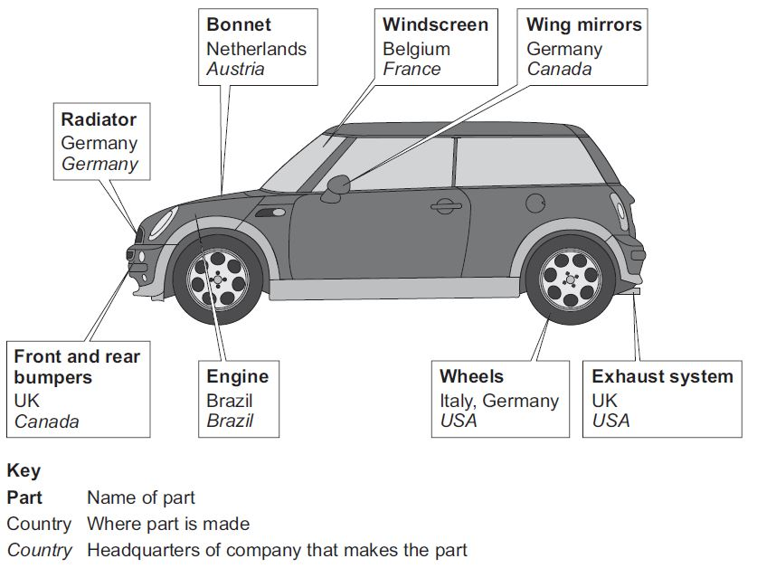
BMI Mini – locations where parts are manufactured

The Mini is assembled in England

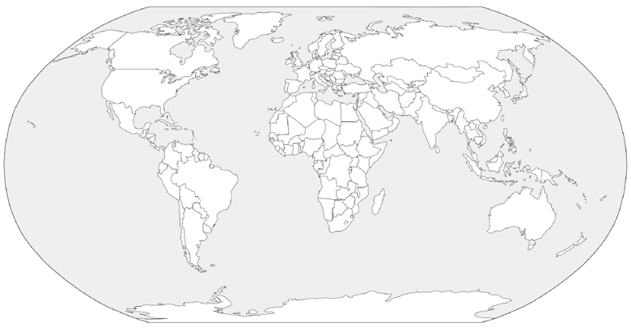

Illustrative example: AID
Australia is a wealthy developed country who has the responsibility to help other countries who might be in need. Australia provides financial assistance, military aid, emergency assistance during natural disasters and education and training as forms of aid to our neighbouring countries.
But what does providing aid to other countries have to do with trade?
The short answer is that if we have countries around us that are struggling economically they will always need our help and become dependent. However, if Australia gave loans, trained and educated people to establish businesses who may become prosperous it is more likely that in the future they will buy and sell goods with us. So providing aid can mean an investment in a future trading partner – someone to buy our goods.
ACTIVITY: if you feel brave, watch the video about foreign aid (a bit old now) from The Weekly, which uses the example of South Korea to make this point.
https://www.youtube.com/watch?v=1ViVkuQyZxI
On a more serious note the Department of Foreign Affairs and Trade works with people in our neighbouring countries to establish entrepreneurs of the future.
ACTIVITY: read the Aid for Trade fact sheet and summarise the advantages of providing aid to other countries by Australia.
https://dfat.gov.au/about-us/publications/Documents/development-cooperation-fact-sheet-aid-for-trade.pdf
_______________________________________________________________________________________
_______________________________________________________________________________________
_______________________________________________________________________________________
_______________________________________________________________________________________
_______________________________________________________________________________________
_______________________________________________________________________________________
_______________________________________________________________________________________
_______________________________________________________________________________________
_______________________________________________________________________________________
_______________________________________________________________________________________

Production and consumption
- What are the effects of producing and consuming goods on a global scale on people, places and environments?
Key Questions:
- What are the environmental, social and economic effects of producing and consuming goods?
- How do governments, groups and individuals respond to the effects of production and consumption of goods?

Illustrative example: Food
Food is an important aspect to the survival of all people of the world, however, not everyone has equal access to food, or good quality foods.
In this example we will look at the cultural influences on diets around the world to see how changing diets and different levels of consumption can have impacts on people, places and the environment.
ACTIVITY: Survey the class of their favourite foods to eat and pick the top 5 to put into the table below.
Most popular foods | Number of people | Country food originated from
1.
2.
3.
4.
5.

ACTIVITY: Graph the results of your class as a column graph.
30
25
20
15
10
5
0
Number in class
Favourite foods
5.
4.
3.
2.
1.

ACTIVITY: Describe the trends in the results from your class survey.
_______________________________________________________________________________________
_______________________________________________________________________________________
_______________________________________________________________________________________
_______________________________________________________________________________________
Effects on places:
Oreos in China
https://www.youtube.com/watch?v=U48nmKPJclA
Word bank:
Increased flavour sweet 1996 wafer
2006 Chinese Oreo smaller
Kraft expanded into in to China in ________ to sell its popular _________ brand biscuit. The sales started to slump in the first few years due to the _____________ of the biscuit not suiting the Chinese diet. Consumers thought the biscuit was too __________.
Kraft decided to trial a recipe of the biscuit which was less sweet and even moved to create a ___________ version of the product which was popular with consumers. In ________ the wafer Oreo was the biggest selling product and with the lightly sweet version of the cookie being released sales _______________.
Oreo was also sold in ____________ packages which are more portable and affordable for consumers, which also increased sales.
Marketing for the Oreo brand has only altered the actors (which are now _______________), preferring to show the traditional method of eating an Oreo biscuit: twist, lick and dunk.

ACTIVITY: Make a list of the ways Oreo/Kraft changed the original Oreo biscuit to suit the Chinese market and make a list of what things they kept the same.
Similarities to the original product | Differences to the original product

ACTIVITY: Where in the world?
Which country were these photos taken in?

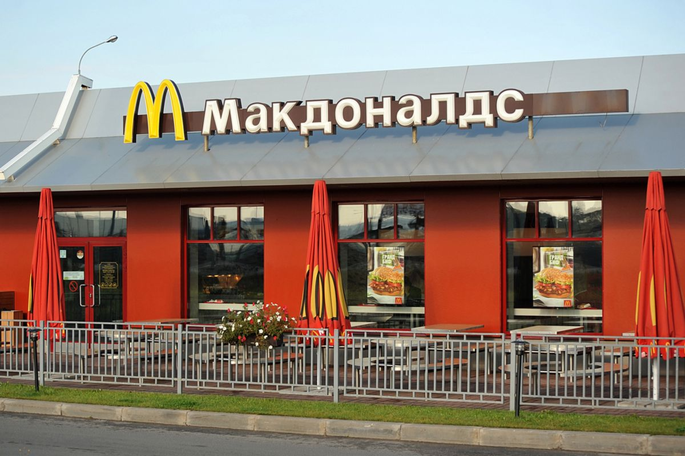 |  | 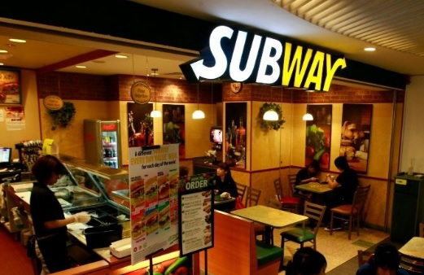
 |  | 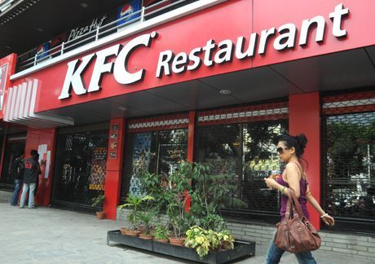
Was it easy or hard to guess? Why?

Effects on people
ACTIVITY: Where is this diet from?
Label the following diets for the country you think they might be from. You might think about a region of the world if you can’t pin point the country.
Rank the diests from best to worst as well.
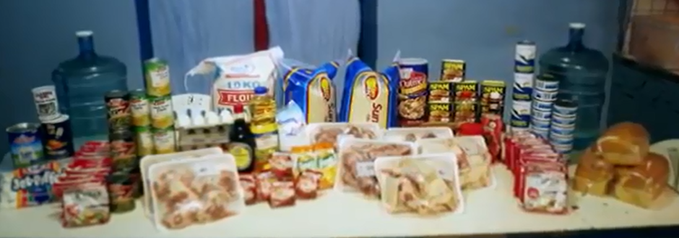

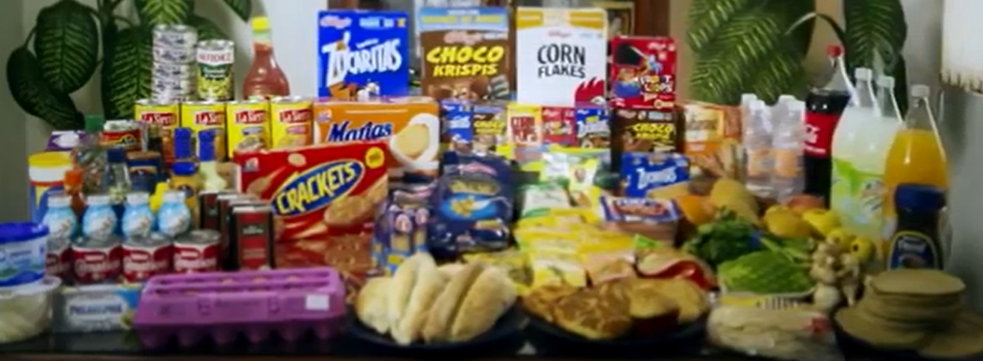

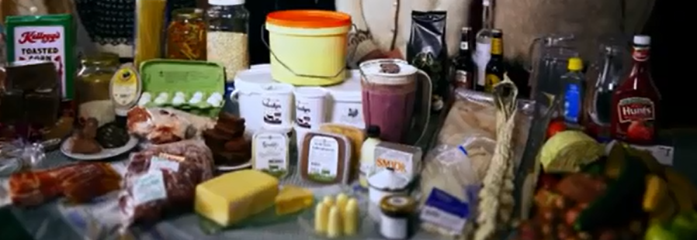

(images from the documentary: World’s best diet)
ACTIVITY: using the images below respond to the following questions
- What do you think the artists of these images is trying to communicate about the consumption of certain foods?
_______________________________________________________________________________________
_______________________________________________________________________________________
_______________________________________________________________________________________
_______________________________________________________________________________________

- Do you think this is a problem across the whole world? Why/why not?
_______________________________________________________________________________________
_______________________________________________________________________________________
_______________________________________________________________________________________
_______________________________________________________________________________________
_______________________________________________________________________________________
_______________________________________________________________________________________

Effects on the environment
The map below show the global value chain of Nutella and where offices, factories and headquarters can be found. IN the production of Nutella, inputs or supplies such as ingredients are sourced from all over the world and brought together to make the product. It is then shipped throughout the globe to retailers to be purchased by consumers.
During this process, the ingredients for Nutella can travel over 24,000km before they are eaten.
This measurement of how far food travels is called food miles. Many people are conscious of this fact and try to buy locally to support farmers and workers, but to also limit the distance food travels.
QUESTION: What is the issue with long food miles for the environment?
_______________________________________________________________________________________
_______________________________________________________________________________________
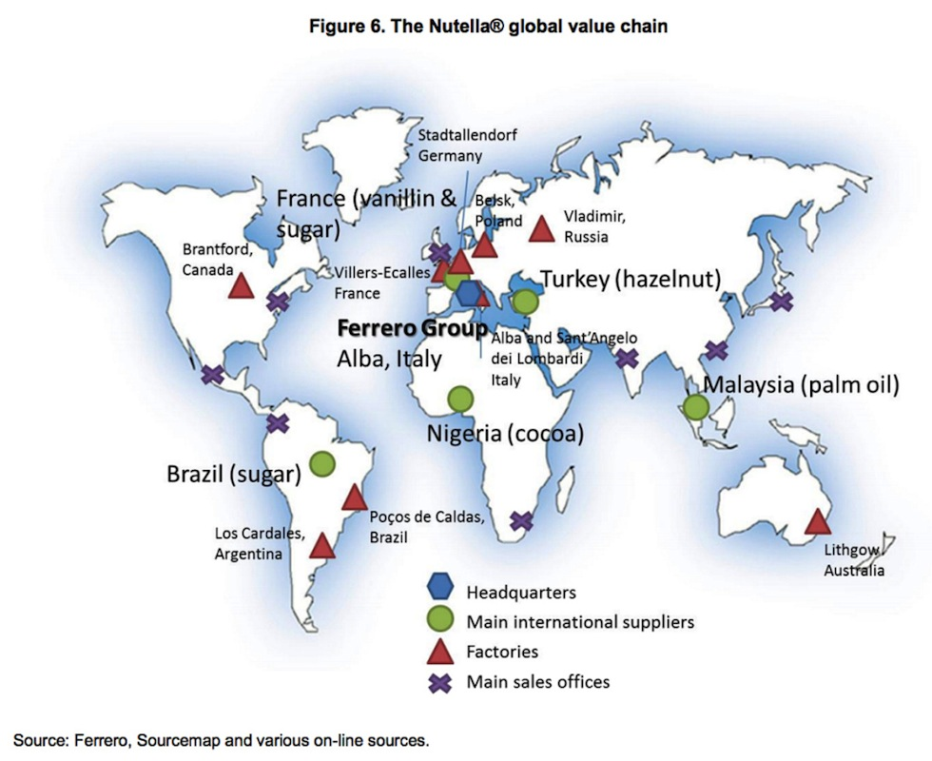
QUESTION: How could you limit your food miles?
_______________________________________________________________________________________
_______________________________________________________________________________________
EXAM PRACTISE QUESTION
Use the source below to respond to the question
QUESTION: Explain the positive and negative effects of global production.















