Water scarcity and water management
Case study: Qatar a country with no water
https://www.ted.com/talks/fahad_al_attiya_a_country_with_no_water
- Watch the clip with your class
- Record THREE surprising facts you learnt from watching this clip
- How did Qatar overcome its water scarcity problem?
- Make a prediction for the future – will they be able to continue consuming so much water?
Water Scarcity
Study the map below on Water shortages and create your own infographic/ poster/ presentation to show water scarcity in the world and ways of overcoming it.
Look at the water.org web site and consider that some students your age spend on average each day collecting water instead to being able to be at school.
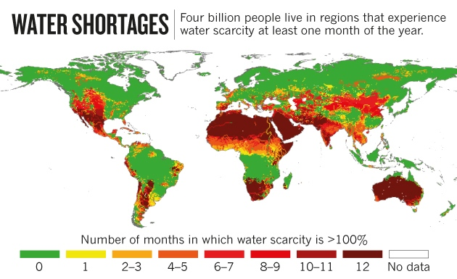
Challenge Activity – Find a good clip on YouTube that shows how to solve water scarcity issues such as providing clean water.
Such as: https://www.ted.com/talks/michael_pritchard_invents_a_water_filter
- State in THREE points that you learnt from this clip.
- Rate this clip from 1-5 (5 the best) and give it a review that explains why others should watch this clip.
- Watch one other students clip and make a comment on it.
Extension Activity – In groups make a list of the ways that you can save water. Create a TV commercial that encourages people to be water wise at home or at school.

