Water in the world – Photo analysis
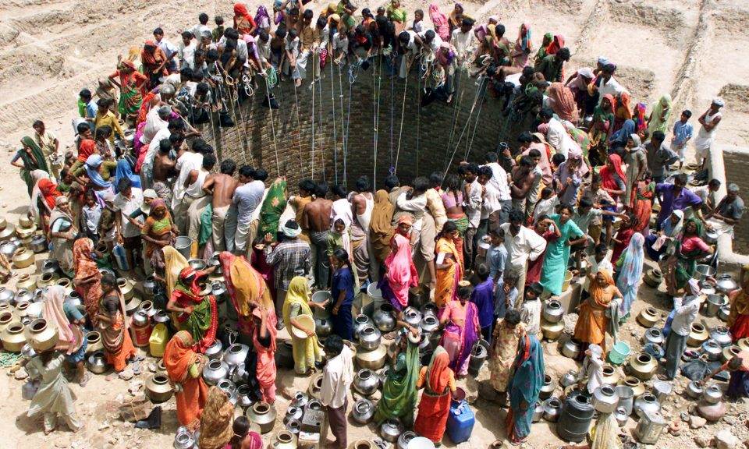
Find an image relating to contamination of water or pressure on water supplies in the world
Answer any 4 of the following questions;

- Where could this photo have been taken? Support your answer with geographical information and a map.

- When might this photo have been taken? What geographical evidence is there to support this?

- What does this photo tell you about a world environment and issue?

- What intention do you think this photo has?

- What emotions or thoughts does this photo evoke in you?

- Who could have manipulated this image? Think carefully about the process from the photograph being taken to the image’s publication.

- What could have led to or caused the situation depicted in the image (e.g. Environment, conflict)

- What could the photographer have excluded from the photo? What is occurring outside the frames of the photograph?
Extra: you could place the photo on a large piece of paper and draw the scene occurring outside of the photographer’s frame. This scene could continue the story the photograph tells, or completely change what is perceived to be happening in the photo.

Glossary of key terms for the water in the world unit- add extra words
Term

Water cycle
Water scarcity
groundwater
Natural hazard
Atmospheric hazard
Hydrologic hazard
Catchment area
Runoff
Seasonal calendar

