Designing an Urban Area:

First, divide the roles among your council.
- The minister of recreation will be in charge of designing venues for entertainment and recreation.
- The minister of infrastructure will be in charge of ensuring there is adequate infrastructure for living, such as roads, transport, electricity etc.
- The minister of services will be in charge of managing health, education and employment services.
- The minister of design will be in charge of making the city or town look aesthetically pleasing.

While each minister has their own responsibilities, you should still consult with each other. Every time you design a new location of any kind, it must be labelled on the town map, and you should identify the best spot for it as a team.

Role | Team Member Name
Minister of recreation
Minister of infrastructure
Minister of services
Minister of design

Now, choose a name for your urban area:
_____________________________________________

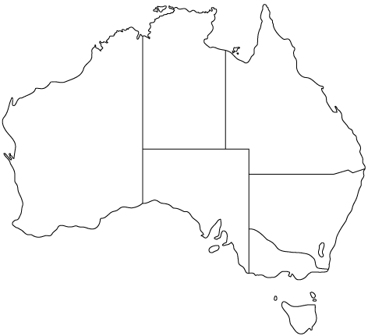
What will the population of your urban area be? (minimum 2000 people) ___________________________

What will be the main source of migration to
your urban area?
__________________
__________________

Where is your town on this map
of Australia? Place a star in its
spot. (it does not matter if there is
already a urban area there)

Describe the climate of your urban area. This must be realistic based on its location in Australia.
Average maximum temperature in January:
Average maximum temperature in July:
Average days of rainfall/year:
Average days of sunshine/year:
Are there any dangers of natural disaster in the area? (flooding, droughts, bushfires, tsunamis, cyclones, etc.)

Draw a climate graph for your urban area.
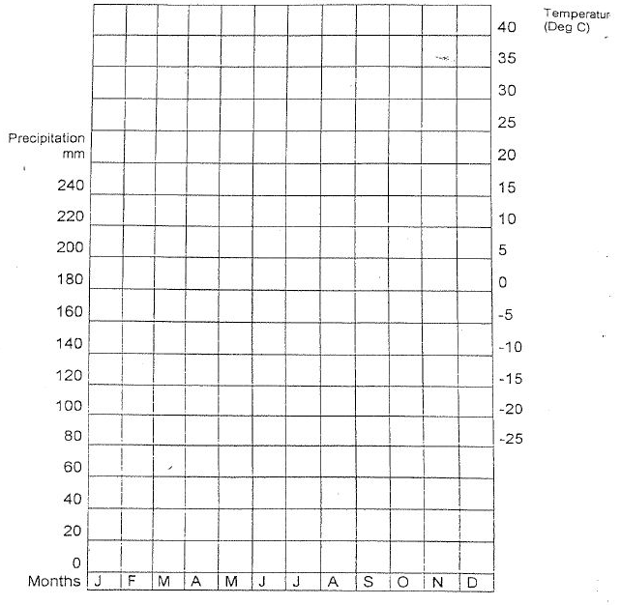
Work together to decide where everything should be located. You may wish to choose some of the major things together first, then discuss other locations as you go.
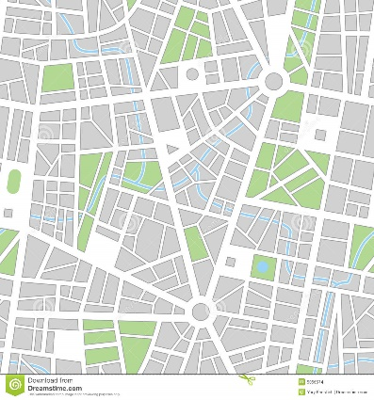

Legend:

Minister of Recreation:

Identify what recreational locations your urban area should have. List AT LEAST 5, with names and descriptions of what they offer and who would enjoy them most, as well as the cost to attend the average activity there (it can be free).

Type of recreation | Name of location | What activities are on offer | Who is most likely to visit | Average cost of activity
e.g. Football Stadium | Telstra Football Stadium | Sporting games and sometimes musical concerts | People of all ages, particularly AFL fans | Tickets to an AFL game range from $20-$200

Creative: Design a pamphlet advertising one of your recreational events to families. Include information on the activity, when and where it is on, why families will enjoy it, and the cost.
Minister of Infrastructure:
Identify the types of infrastructure your urban area needs. Research technology that will help you have the best possible options.

Infrastructure | Technology | Example of success elsewhere
e.g. Roads | Temperature monitoring dynamic paint | Brabant, The Netherlands:  They use this technology to help warn drivers of ice ahead, to make their roads safer. They can also warn if the road is particularly hot, which might cause reflective glares that are dangerous for drivers

Creative: Design a transport map to help people get around. You need taxis, and buses/trains to take citizens from your town to others in your region. If your urban area has over 10,000 people, you need local buses. If your urban area has over 100,000 you also need a train system.

Transport Map:

B
Bus stops Bus lines in colour:
T
Train stops Train lines in colour:
Taxi rank
Car parking
P

Minister of Services:

Identify the types of services your urban area needs. Consider education, health, employment, community, safety and other services. Make these realistic to the size of your town, and ensure they are helpful depending on the needs of your population.
Service | What it offers | Why your people need it
e.g. Dentist surgery | Oral hygiene and orthodontic work | Our town has lots of young people, who often need braces/dental work. We also have lots of retirees who may need help looking after their teeth in old age.

Creative: One of your chosen services is holding a fundraiser! Decide how they will raise money, create a budget for any equipment needed, and then design a flyer to advertise your fundraiser to the community.

Minister of Tourism: Identify tourist attractions your town needs. These could be natural, cultural, historical or adventure based activities. Consider your location and what might attract tourists to the area.

Tourist Attraction | Category (natural, cultural, historical or adventure based) | Describe the activity | Who would visit the area for this attraction?
e.g. Botanical Gardens | Natural | Our Botanical Gardens are home to a variety of native and imported plant life. Enjoy a beautiful walk or picnic. We also host free educational events for people to learn about botany. | Nature lovers, people who are looking for affordable activities, families who want outdoor space for children

Creative: Design an advertisement for your town, using your tourist attractions to entice visitors. It may be a tv advertisement using photos/music, a radio advertisement, or a billboard for the highway.

As a whole team once your ministers have developed their plans:

Identify 3-4 major pull factors that will cause people to move to your urban area:
- ___________________________________________________________
- ___________________________________________________________
- ___________________________________________________________
- ___________________________________________________________
Identify 1 potential issue your urban area may face if urbanisation increases rapidly:
- ___________________________________________________________
Propose a solution to this issue, identifying a short-term plan of what your local council will do NOW to prepare for this issue, as well a long-term plan of what your council will do in the future to manage this issue when it emerges.
Short-term plan:
Long-term plan:
Finally, look over your whole plan, and conduct a SWOT analysis of your urban area.

Strengths: (existing features of your urban area that will make it a success) | Opportunities: (ways your urban area can continue to improve future)
Weaknesses: (existing features of your urban area that may cause challenges) | Threats: (ways your urban area may face difficulties/challenges in future)

