Geography Skills Year 9
Latitude and Longitude Pt.1  Latitude and longitude are used as a coordinate system that enables every location on Earth to be specified by a set of numbers, letters or symbols.  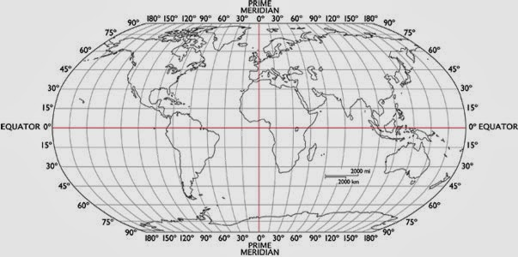  Tricks to remember which is which:  - “Lat is flat” read the flat lines to find latitude  - “Longitude is on the long side of the map” see map on previous card, you would read the numbers along the bottom to determine longitude  When writing out coordinates, latitude should be written first, followed by longitude (You can remember this alphabetically lat comes before long). | Latitude and Longitude Pt.2  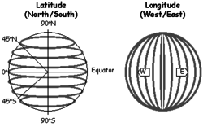  Latitude and longitude are written in degrees ( ⁰ ), minutes ( ‘ ) and seconds ( “ ).  Examples:  36⁰ N, 122⁰ W  12⁰ 54’ S, 135⁰ 15’ E  44⁰ 23’ 31” N, 75⁰ 49‘ 8“ W
Latitude and Longitude Pt.3  Study the map and answer the questions:  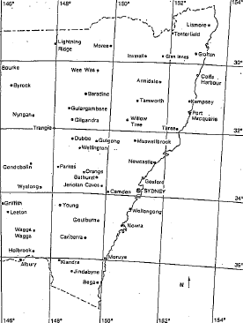 | Latitude and Longitude Pt.4  When calculating latitude and longitude, ensure you check the difference in intervals between the lines. In the case of this map, the lines have intervals of 2⁰.  - Estimate the latitude and longitude coordinates of these places:  - Wollongong  - Tamworth  - Nowra  - Young  - Grafton  - Which place in NSW is closest to these coordinates?  - 32⁰S 148⁰E  - 31⁰58’ S 152⁰21‘ E  - 34⁰27’ S 146⁰05’ E  - 33⁰57’ S 150⁰03’ E  - 32⁰32’ S 149⁰ E

Around the World! (Lat and Long) Pt.1  Individual activity. Time to go around the world! Use an atlas (or Google Maps), follow the steps below, and create a travel diary in your book as you go:  For each set of coordinates (latitude and longitude) provided, enter the city and country.  Name two significant landforms in the region.  List two facts about the culture or cultures in the region (language, religion, occupation, lifestyle).  List two odd, interesting, or historic facts about the region or its people.  EXAMPLE TRAVEL DIARY ENTRY:  Arrive: 38°30’N 90°W St. Louis, United States  Landforms: 1. Mississippi River  2. Ozark Mountains  Culture: 1. Service industries make up 73% of the economic activity.  2. 85% of the people are Christian, but more than 1,000 religions are practiced.  Odd Facts: 1. September 11, 2001 - suffered the worst terrorist attack in history.  2. Central region suffers from many tornadoes – very rare anywhere else in the world. | Around the World! (Lat and Long) Pt.2  Depart: 49°N 123°W  City/Country:  Landforms: (x2)  Culture: (x2)  Facts: (x2)  Arrive: 19°30’N 99°W  Arrive: 34°S 18°30’E  Arrive: 30°N 31°E  Arrive: 40°30’N 3°30’W  Arrive: 56°N 37°30’E  Arrive: 22°30’N 88°30’E  Arrive: 40°N 116°30’E  Arrive: 6°S 107°E  Arrive: 34°S 151°E  Return home!
Battleships (Lat and Long)  Partner activity. Draw a grid in your book like the one below or find a version on the internet.  - Place your ships on the lines.  - Read the north/south number (latitude) first, then the east/west (longitude) number. If you read in the incorrect order, your partner will call “misfire” and you miss your turn.  - Mark your ships in blue, and your guesses in red.  - Follow all other typical Battleship rules.  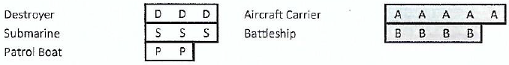  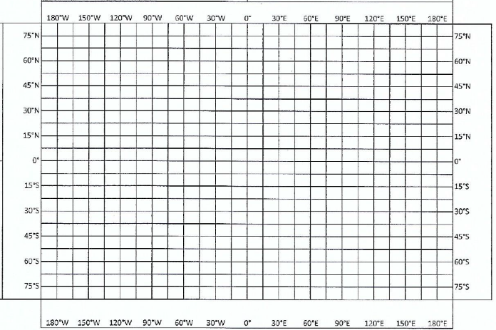 | Area References Pt.1  Many maps have a grid of lines printed over them. The lines go across and down. Each line has a number. These numbers can be used to show the position of something on the map.  These grid lines are called eastings (numbers along the top/bottom that get bigger going towards the East) and northings (up the side/s that get bigger going towards North).  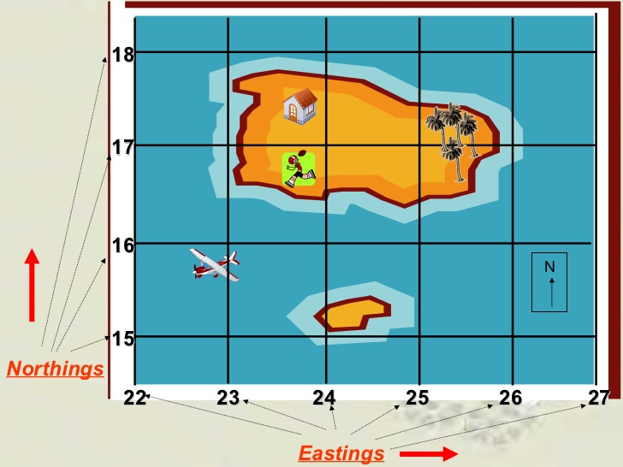

Area References Pt.2  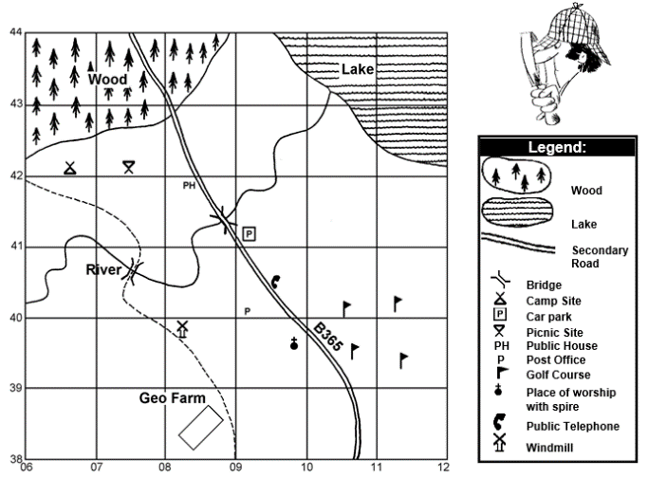  When you are asked to find the area reference, you are looking at anything that is inside one of these grid boxes, e.g. the Geo Farm in the map above is in AR0838.  If an item goes over multiple boxes you determine the reference by using the box that is the most covered, e.g. the lake in the map above is in AR1143.  AREA AND GRID REFERENCES MUST BE WRITTEN WITH THE EASTINGS NUMBER FIRST, FOLLOWED BY THE NORTHINGS NUMBER you can remember this alphabetically, E comes before N. | Area References Pt.3  How to find a 4-figure area reference:  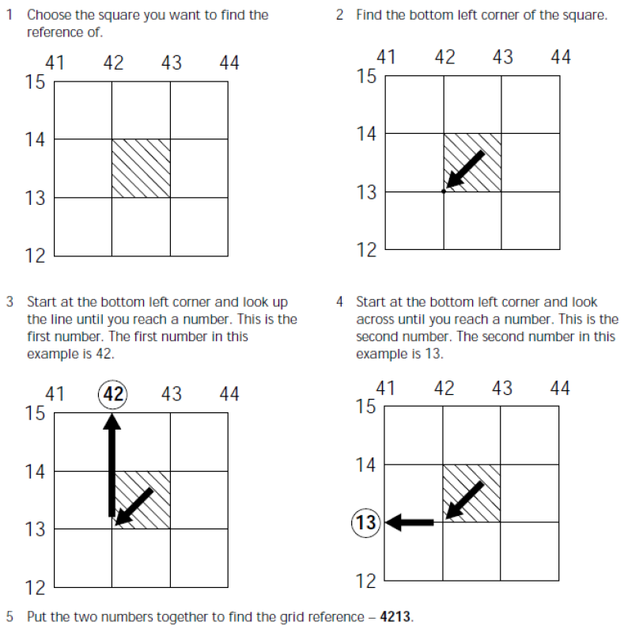
Area References Pt.4  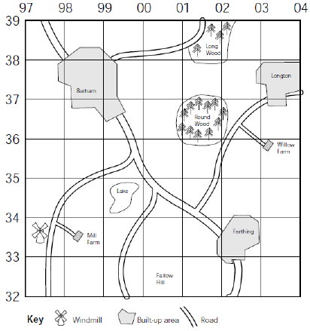  Individual activity. Use the map below to answer the questions on the next card. | Area References Pt.5  Reminder, when looking for area references, always go from the bottom left of the box the item is in to find the correct reference numbers. Eastings numbers (across the top/bottom) must come first, followed by Northings (up the side).  - What is the area reference of:  - The village of Barham?  - The village of Farthing?  - Round Wood?  - The windmill?  - Willow farm?  - What is found at the following area references?  - 0337  - 9833  - 0138  - 9934  - 0032

Tic-Tac-Toe (Area Reference Style)  Partner activity.  Step 1: Draw an extended tic-tac-toe grid in your book including area reference numbers like the example below (you can choose different numbers for each round).  Step 2: Choose whether you will be naughts or crosses. Your aim is to get five noughts/crosses in a row – vertically, horizontally, or diagonally.  Step 3: The difference to regular tic-tac-toe is that you need to name the area reference box in which you would like your symbol to go, and your partner will place your symbol for you (to test your knowledge of area references). If you get the order incorrect, you will lose a turn.  11 12 13 14 15 16  46  45  44  43  42  41  40 | Grid References Pt.1  Grid references are like area references, working off a grid that sits over a map. Grid references are a more specific method used to find items on a map.  How to find a 6-figure grid reference:  In your head, you should be able to divide all sides of the square into ten equal sections. By doing this, you can pinpoint locations within the square – these are called six-figure grid references. Remember, you need to read these numbers off the imaginary lines as well, not the centre of the square.  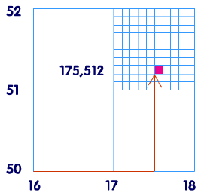  Eastings  Northings  5/10 (half way) of the way to the next eastings  2/10 of the way to the next northings  175 512
Grid References Pt.2  Individual activity. Use the map below to answer the questions on the next card.  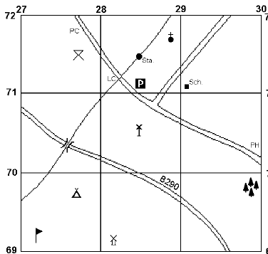 | Grid References Pt.3  Reminder, when looking for area OR grid references, always go from the bottom left of the box the item is in to find the correct reference numbers. Eastings numbers (across the top/bottom) must come first, followed by Northings (up the side).  - What is the grid reference of:  - The bridge  - The windmill  - The golf course  - The station  - The sign  - What is found at the following grid references?  - 288717  - 291711  - 298698  - 285711  - 277715

Design Your Own Map (Area and Grid Refs)  Partner activity.  Step 1: Draw a grid in your book that looks the same as example on the right  Ensure you add area reference numbers around the outside of your grid.  Step 2: Draw your own map inside the grid. Use symbols to represent objects (e.g. use to represent a church). Make sure you include a legend/key.  Step 3: Write area and grid reference questions relevant to your map.  Step 4: Swap maps with your partner and have a go at completing their questions. | Mapping Skills Pt.1  When labelling maps, make sure you use BOLTS:  B – Border (An outline or box which encloses the map)  O – Orientation (Direction – usually a north arrow or compass diagram that shows the direction of north)  L – Legend (Key – a list which explains what each symbol, colour or pattern means on the map)  T – Title (A heading that describes what the map shows)  S – Scale (Shown as a line, a ratio or in words, that indicates distances in real life)  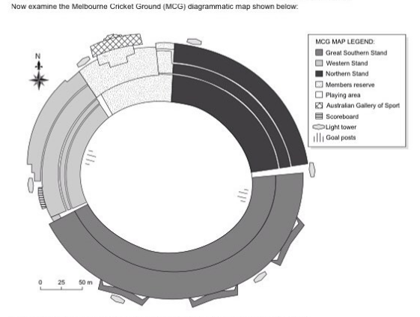  Melbourne Cricket Ground
Mapping Skills Pt.2  Individual activity. In your book draw a map of an imaginary island. Make sure you include lots of detail and add BOLTS to your map.  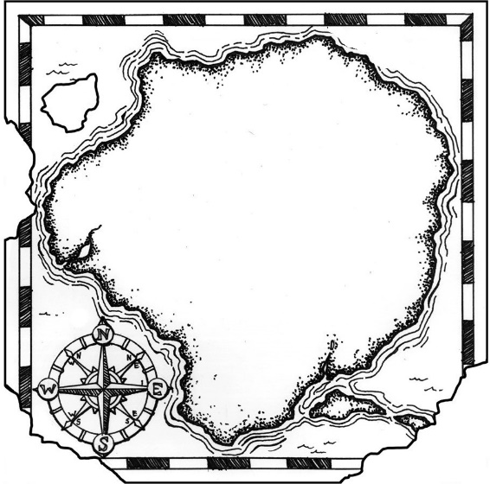  You can make up your scale, but it should be written in the form of 1cm= _____ km. | Australian Geography Foldable Pt.1  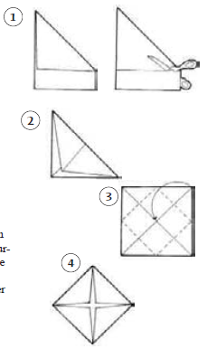  Step 1: fold a piece of paper following the diargram below.  Step 2: Looking at your paper as in part 4 of folding, write “Great Barrier Reef”, “Plants and Animals”, “Economy”, and “Tourism” on each triangle.

Australian Geography Foldable Pt.2  Step 3: Unfold your paper so you are looking at the inside. In the centre square (step 3 in folding diagram), draw a map of Australia, then Draw, label, and/or color all of the following:  - Canberra  - Great Barrier Reef  - Darling River  - Murray River  - Great Dividing Range  - Uluru (Ayers Rock)  - Indian Ocean  - Pacific Ocean  - Southern Ocean  - Great Sandy Desert  - Great Victoria Desert  - Simpson Desert  - At least 4 lines of longitude (+ labelled)  - At least 4 lines of latitude (+ labelled)  - Orientation/compass rose  - Title  - Scale  - Legend  Step 4: Underneath the “Great Barrier Reef” triangle, explain what the Great Barrier Reef is, what it’s like, and why it’s important. | Australian Geography Foldable Pt.3  Step 5: Underneath the “Plants and Animals” triangle, list a few examples of plants and animals native to Australia. Also name some invasive species and explain why are they a problem in Australia?  Step 6: Underneath the “Economy” triangle, discuss which natural resources are available in Australia. Also discuss some ways that Australians make money.  Step 7: Underneath the “Tourism” triangle, you can talk about Australian tourism in general or you can give specific Information about a place to visit or an activity that someone could do in Australia.  Step 8: Glue your foldable into your book.
Population Pyramids Pt.1  A population pyramid is a pyramid-shaped diagram illustrating the age distribution of a population; the youngest ages are at the bottom ascending in age till the oldest age at the top of the pyramid.  How do you read a population pyramid?  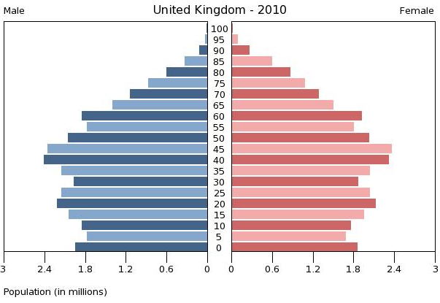  1  2  2  3  4  - The title of the Population Pyramid. Usually, this is the name of the location along with the year.  - The left side of the pyramid shows the population distribution of the males while the right side shows the population distribution of the females of the location.  - Horizontal axis shows the populations (in this case) millions.  - Vertical axis lists the age group; typically, by five-year increments | Population Pyramids Pt.2  Types of population pyramids:  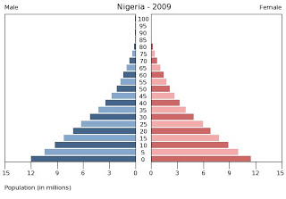  Rapid Growth Population Pyramid  This type of population typically has poor health care and short life expectancies. Mostly found in under developed and developing countries.  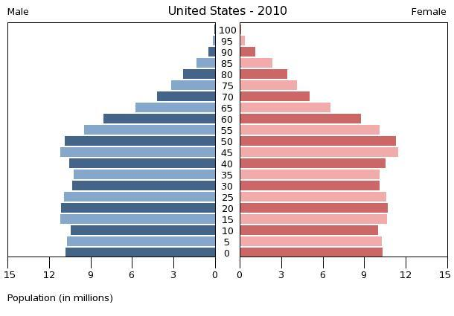  Slow or Stable Growth Population Pyramid  This type of population is mostly found in developed countries sometimes middle-income countries. These countries have good health care, long life expectancies and stable governments.  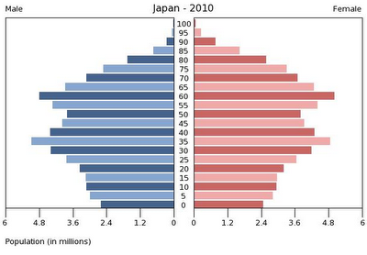  Negative or Declining Growth Population Pyramid  This type of population is mostly found in developed countries. These countries have good health care, long life expectancies and stable governments. However, their birth rates are lower than needed to replace the population.

Population Pyramids Pt.3  Individual activity. Create a population pyramid in your book for Brazil in 2010 using the data then answer the questions.  AGE GROUP POP IN MILLIONS  Male Female  65+ 2.1 2.6  60-64 3.0 3.5  55-59 4.0 4.3  50-54 5.0 5.3  45-49 6.0 6.2  40-44 6.6 6.7  35-39 7.1 7.2  30-34 8.0 8.0  25-29 8.8 8.7  20-24 8.7 8.5  15-19 8.5 8.2  10-14 8.7 8.4  5-9 8.7 8.3  0-4 8.0 7.7  - Does this population pyramid show rapid, stable or negative growth? Why?  - Why are there more females than males in the older age groups?  - What factors must a stable growth country focus on to remain stable? | Direction Pt.1  Direction is a fairly simple geographical skill. It is important to note that bearings are a much more specific means of determining direction. The main compass points (N,S,E,W) are known as cardinal directions, and the points in between are ordinal directions. Examine the more detailed direction diagram below:  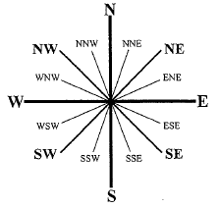  The most important thing about determining direction is reading the question carefully. Most questions will ask where is X from Y. If you answer where is Y from X, you will get the anwer incorrect.
Direction Pt.2  Individual activity. Study the map and answer the questions:  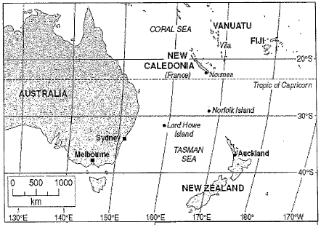 | Direction Pt.3  - What is the direction:  - From Noumea to Lord Howe Island?  - From Auckland to Lord Howe Island?  - To Sydney from Melbourne?  - From Noumea to Norfolk Island?  - To Norfolk Island from Sydney?  - Name a place that is found:  - East of Melbourne.  - NE of Noumea.  - WSW of Lord Howe Island.  - NNW of Auckland.  - SSW of Vila.

Bearings Pt.1  As you have seen, direction has some limitations, where one direction may not quite “fit” – for example, a direction might be in between north eat and NNE, which creates uncertainty to the correct answer. With the use of bearings, this uncertainty is removed.  A bearing is a measurement of degrees, relating to the 360⁰ of a circle. It is based on the arms of a compass, but the direction names are replaced with numbers showing degrees from 0 (which is North).  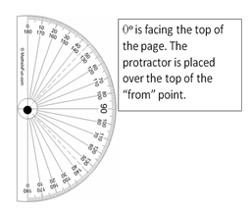  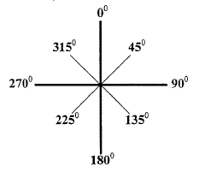  You may use a protractor to help you gain a precise measurement. Place the centre of the protractor on the “from” point, with 0⁰ pointing to the top of the page. Where the line crosses through the protractor you need to measure the angle. | Bearings Pt.2  Individual activity. Study the map and answer the questions:
Bearings Pt.3  - What is the bearing:  - Of Willow Tree from Griffith?  - Of Coffs Harbour from Jenolan Caves?  - Of Orange from Lightning Ridge?  - Of Canberra from Taree?  - Of Nyngan from Jindabyne?  - Write the correct answer using full sentences:  - The bearing of Wagga Wagga from Moruya is closest to:  265⁰ 275⁰ 285⁰ 295⁰  - The bearing of Inverell from Byrock is closest to:  73⁰ 75⁰ 77⁰ 79⁰  - The bearing of Leeton is about 2790 from which place on the map? | Climate Graphs Pt.1  A climograph or climate-graph is a combination of a line and bar graph to illustrate what a particular place’s weather is like. The graph uses a place’s average temperature and precipitation.  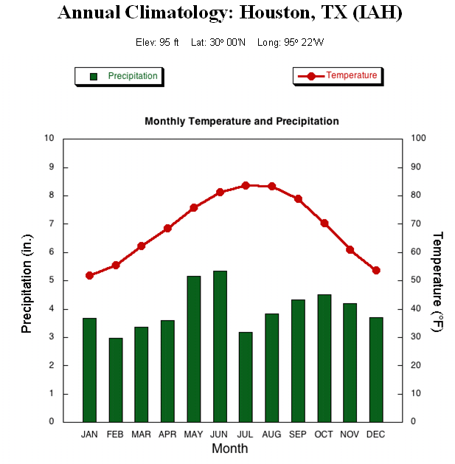  How do you read a climograph?  1  2  3  4  5  6

Climate Graphs Pt.2  - Title of the climograph; which typically is the name of the place that the climograph is showing.  - A scale used to indicate the amount of precipitation. On this graph is in inches but could also be shown in the metric system.  - A scale used to measure temperature. On this graph it is measured in degrees Fahrenheit but could also be in degrees Celsius.  - The months of the years. On this climograph they show the months with a three letter abbreviation but many graphs just use the first letter of the month.  - A line graph showing the average monthly temperature during the year.  - A bar graph showing the average monthly precipitation during the year.  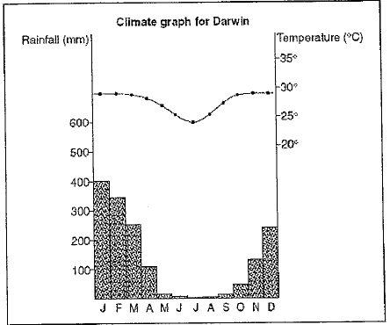  Sometimes the scales used in climographs need to be higher/lower on the graph as shown to the right when there is wide range in temperatures and precipitation: | Climate Graphs Pt.3  Individual activity. Create a climograph in your book for Canberra, Australia using the data in the table.  Make sure you include:  - A title  - An appropriate scale (for temp and preciptation)  - Use Australian metrics (mm and degrees celcius)  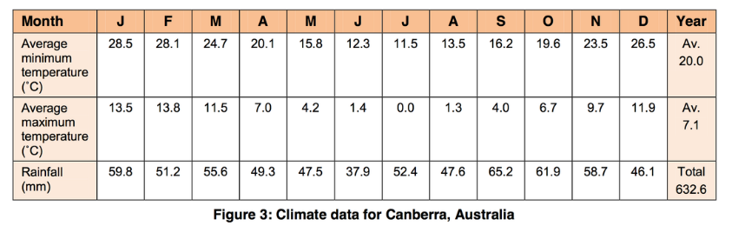
Interpreting Climate Graphs Pt.1  Individual activity. Use the climographs below to answer the questions (note that the temps are written in Fahrenheit):  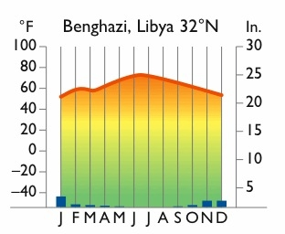  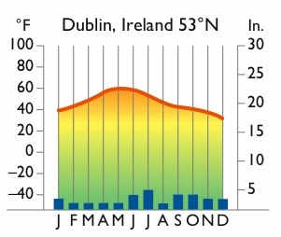  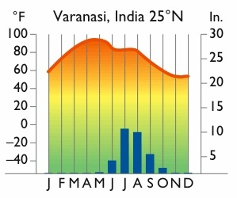 | Interpreting Climate Graphs Pt.2  - Which of these places has the most year-round precipitation?  - Which of these places has the least year-round precipitation?  - Which of these places has the coolest temperatures?  - Which place has the most variable (changing) climate?  - Which place has the most consistent year-round temperature?  - In which month(s) does Benghazi, Libya receive no rainfall?  - Compare the average December temperature of the three cities. What similarities do you see?  - When are the hottest temperatures in Varanasi, India?  - What is Dublin’s temperature range? (Show your working).  - In which of these three places would people most likely live? Why?

Weather Maps Pt.1  There are a number of common symbols used on weather maps. Study the table below then complete the activities on the following cards.  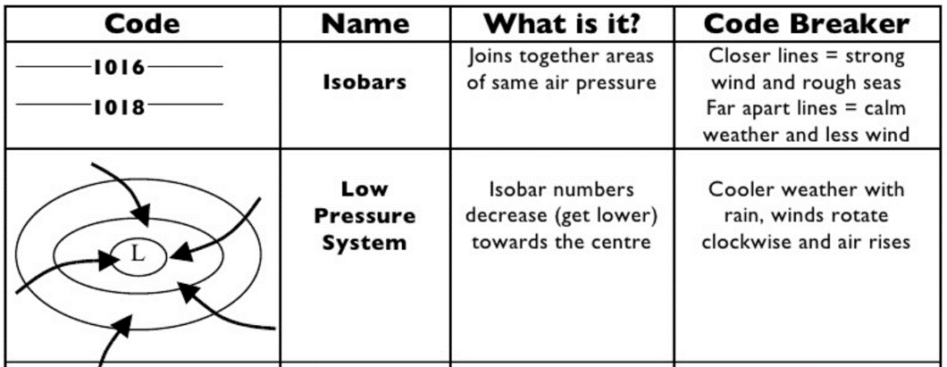  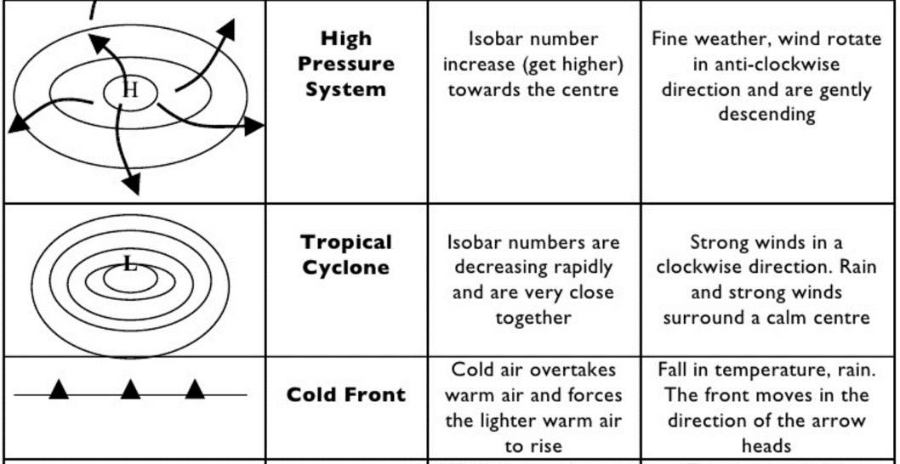  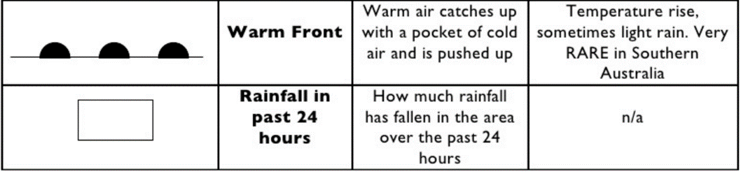 | Weather Maps Pt.2  Individual activity. Study the following map and answer the questions:  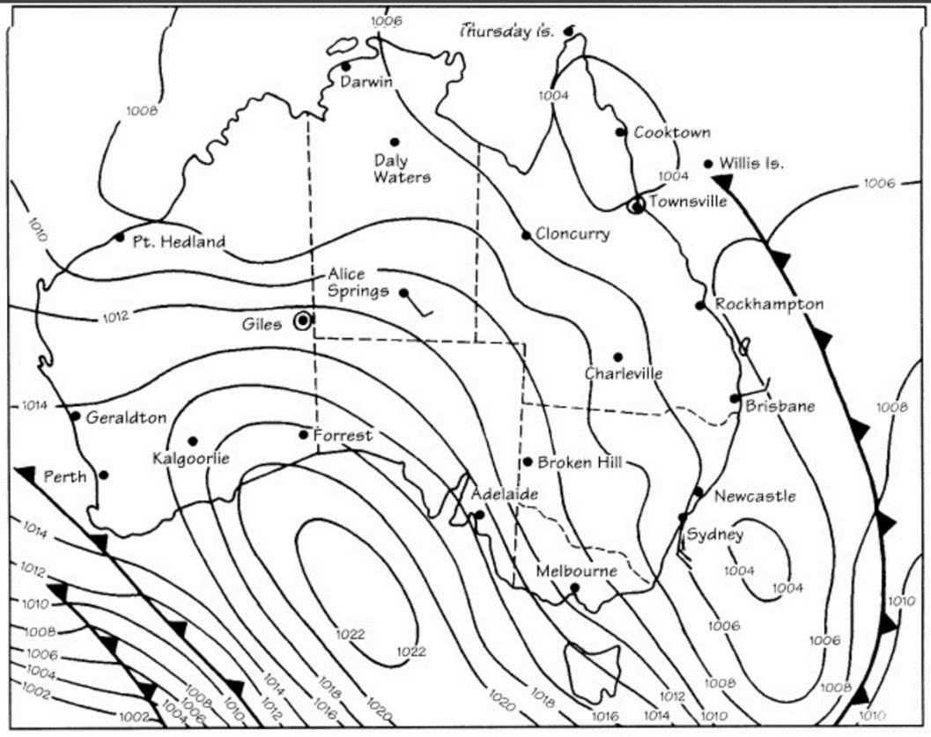  - Name one location on the map where a high pressure system is present.  - Name one location on the map where a low pressure system is present.
Weather Maps Pt.3  - Estimate the air pressures at the following locations:  - Alice Springs  - Townville  - Complete the following table:  Location Wind Speed Wind Direction  Alice Springs  Brisbane  Sydney  - Name two centres on the map that are experiencing calm conditions. | Wind Speed and Direction Pt.1  The wind symbol will point in the direction from which the wind is blowing.  The wind from the fan is blowing to the left (to the west). This means it is coming from the East, making it an Easterly wind. The “tail” of the wind symbol points in the direction of East.  The little “sticks” or “triangles” on the symbol indicate the wind speed. This is measures in knots. 1 knot = 1.9km per hour.  Each short stick represents 5 knots.  Long sticks represent 10 knots.  A triangle represents 50 knots.  You find the wind speed by adding the numbers together. If there is a line with no “sticks” or “triangles” it means that there is no wind.

Wind Speed and Direction Pt.2  Individual activity. Practice determining wind speed and direction:  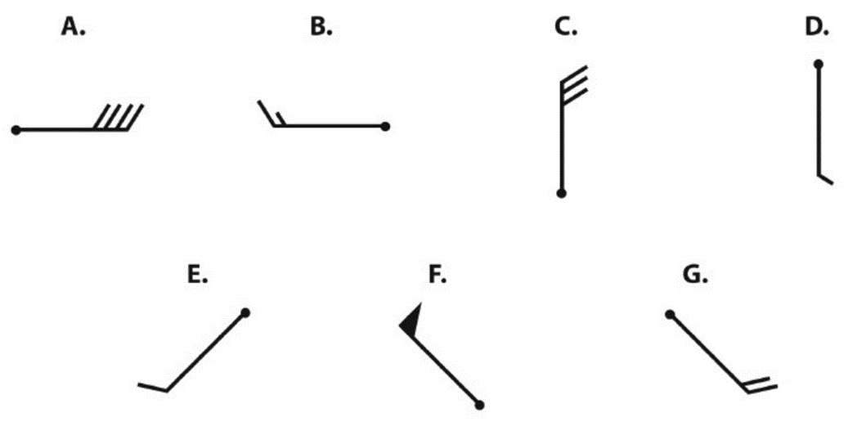  Symbol Direction Speed  A Blowing from the east 40 knots  B  C  D  E  F  G  s | Scale Pt.1  Scale is needed as maps of a given area are much smaller than the area itself. Scale can be shown in a linear method or a ratio method.  The linear method:  In many cases this shows that 1cm on the map =1km in real life.  This can be problematic when 1cm=800km there is too much guesswork in calculating specific distances.  The ratio method:  This is when scale is represented by using a ratio.  Example  - Ratio is shown as1:50,000  - This means that 1cm on the map = 50,000cm in real life.  - As 50,000cm doesn’t mean much, we change it like this…  1cm=50,000cm (there are 100cm per metre, which means we can move the decimal place back 2 spaces)  Therefore, 1cm= 500m
Scale Pt.2  Individual or partner activity. Convert the following to ratio scales in your book. Show your working.  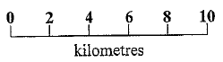  - 1cm = 500km  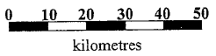  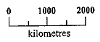 | Distance  Individual activity. Look at the map and complete the questions based off the scale.  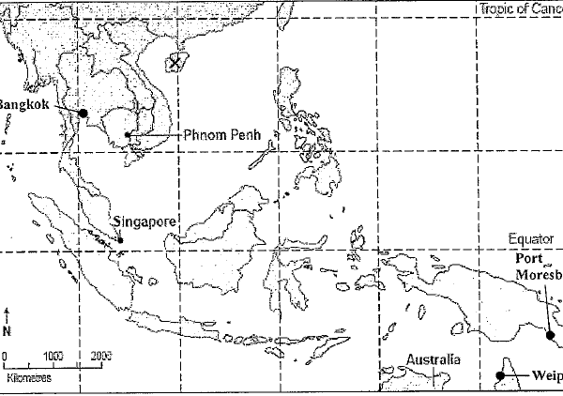  - Calculate the distance between:  - Singapore and Phnom Penh  - Phnom Penh and the middle of Hainan Dao (island X)  - Bangkok and Phnom Penh  - Port Moresby and Weipa

Local Relief Pt.1  Local relief refers to the difference in elevation between the highest and lowest points in a given area. This is calculated by examining a topographic map (or a given area), finding the highest and lowest points shown, then subtracting one from the other to get the difference.  Example:  If a hiker was to walk from Point A to Point B, what local relief would be experienced?  This is answered by:  Highest point (D) = 300m -  A  B  100m  300m  185m  Lowest point (A) = 100m  Local Relief = 200m | Local Relief Pt.2  Individual activity. Calculate the local relief in the area shown  (show your working).  177  100  Spot height (m)  Contour interval: 10m
Gradients Pt.1  Another term for gradient is ‘steepness’. Gradient is a measure of how steep a slope is between two points. A contour line shows you the land’s height above sea level, and you use these contour lines to work out the gradient. The closer together the contour lines, the steeper that part of the slope is.  Rise  Run  Gradient =  Example:  If you were asked to calculate the gradient between point A and point B in the diagram, you need to:  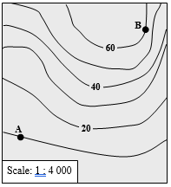  - Difference in height  = 60m – 10m  = 50m (Rise)  - Distance between points  = 5cm  Scale = 1:4000, meaning 1cm=40m  Therefore distance  = 5x40m  =200m (Run)  - The gradient  =50/200  = ¼ or 1:4 (a rise of 1m in every 4 metres) | Gradients Pt.2  Individual activity. Use this map to answer the following questions:  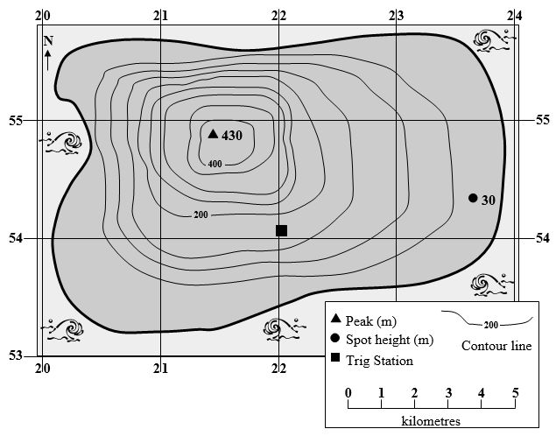  - Calculate the gradient between the peak in AR 2154 and the spot height at GR 237543.  - Provide the grid reference for the point where the slope has a steep gradient and a northerly aspect.  - What is the local relief in AR 2154?

Aspect Pt.1  Aspect refers to the direction that a slope faces. A good way to answer a question is to ask: “If I was standing on that slope, facing downhill, in which direction would I be looking?”  In order to answer an aspect question, you need to find the direction indicator on the map to check where north is. Usually it is straight up, but it’s best to check anyway. Once you have established where north is, aspect can be calculated.  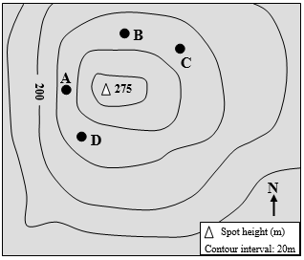  Example:  The north indicator on this map shows that north is straight up. Looking at the contour lines, you can see that this area is a hill top that slopes down on all sides.  If you were standing at point A, and facing downhill (that is, away from the peak), you would be facing towards the left of the map. This is west. | Aspect Pt.2  Individual activity. Use this map to answer the following questions:  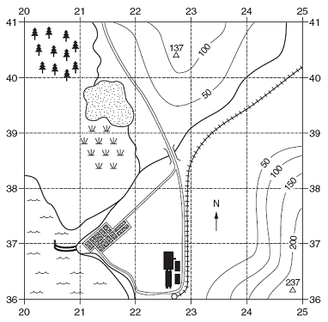
Aspect Pt.3  - Which of the following locations provides the best site for the planting of a tree species that requires a NW aspect and a well-drained site?  - GR 203406  - GR 246382  - GR 212389  - GR 234403  - Provide a grid reference for a point on the slope that has a south-easterly aspect.  - Provide a grid reference for a point on the slope that has a westerly aspect.  - Out of the two grid references you have just provided, which one has the steepest gradient? Show your workings.  - The railway line is the feature shown like this:  Write the height of the railway line above sea level. | Create a Country Pt.1  Individual activity. In your book, complete the following activities to create your own country.  Questions:  - What is the name of your country?  - What is your country’s capital?  - What continent is your country on?  - What is the population of your country?  - What is the climate of your country like (does it ever change or does it stay the same)?  - What are your countries natural resources (oil, gold, diamonds, etc.)?  - What religions are practiced in your country?  - What languages are spoken in your country?  - What type of government runs your country (democracy, dictatorship, communism, socialism, monarchy, etc.)?  - What is your ruler called (president, king, Caesar, czar, emperor, etc.)?  - What agricultural products are grown in your country?

Create a Country Pt.2  Questions cont.:  - What holidays are celebrated in your country (Name at least 5 & explain them)?  - What type of animals (wildlife) are found in your country?  - What is your country’s national motto (saying that represents your country)?  Drawing:  - Draw your country’s “symbol”/coat of arms, e.g. this is Australia’s coat of arms:  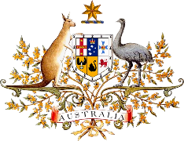  - Draw and colour your country’s flag.  - Draw a map of your country. Make sure to label landmarks such as roads, bridges, cities (place a star for the capital), rivers, lakes, amusement parks, mountains, and any other attractions. Must be coloured and have at least 25 labelled landmarks. You may include a key if you would like. | World Mapping Features Pt.1  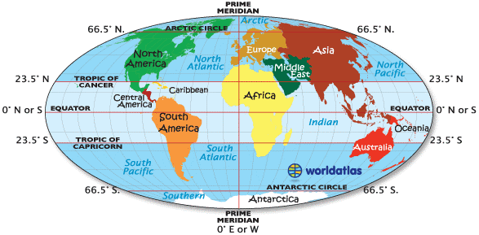  There are 4 imaginary lines that help us to divide up our globe.  - Running vertically through the centre of the Earth is the Prime Meridian. Along this line counts as 0⁰ longitude and is also the start of the international date line for time zones.  - Running horizontally through the centre of the Earth is the Equator. Along this line counts as 0⁰ latitude and separates the Northern and Southern Hemispheres.  - Above the equator at 23.5⁰N latitude, is the Tropic of Cancer.  - Below the equator at 23.5^{0S} latitude, is the Tropic of Capricorn.
The Amazing RACE! Pt.1  Partner activity. Today you will embark on the amazing race! An internet research task, you need to race a partner to find the correct answers to the following questions. The aim is to both improve your World Geography AND researching skills – best not to type in the full question, make sure you use key words to search. The first one to have correct answers for all questions is the winner!  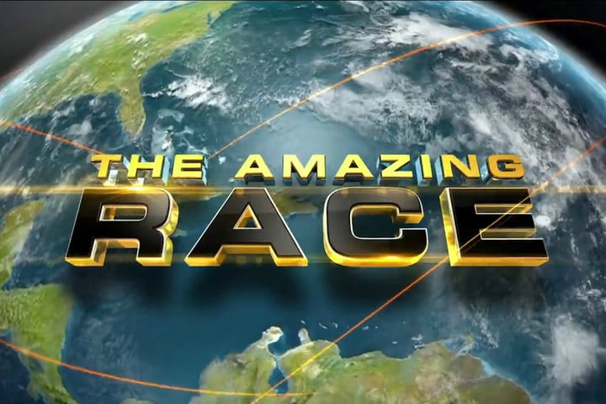 | The Amazing RACE! Pt.2  Questions cont.:  - What is the capital of the United States of America?  - What is the unique design on the Canadian flag?  - What type of dance originated in Argentina in the late 1800s?  - In which country will you find the largest zoo in the world with over 1500 species and 14,000 animals?  - In what country was the first postage stamp, the penny post, created?  - In which country would you find Mount Olympus, home of the ancient gods?  - What ancient civilisation originated in what is now Pakistan, but disappeared after 1000 years of existence?  - What is the smallest country in the world? Where is it located?  - Where is the highest mountain in the world located?  - What island nation is made up of volcanoes, some of which, including Mt. Pinatubo, have been the largest eruptions in history?

The Amazing RACE! Pt.3  Questions cont.:  - Besides Vatican City, what two countries lie completely within the borders of another country?  - Where would you find the largest gold statue, the Golden Buddha?  - Where would you be able to see the world’s largest pyramid?  - What railway system crosses over 3901 bridges and 8 time zones?  - What is the largest living (sea) structure in the world?  - Where would you find the largest rainforest in the world?  - What is the Southernmost continent on Earth?  - What is the second largest desert in the world?  - What ocean makes up over 30% of the Earth’s surface and was named by the explorer, Magellan?  - What is the largest city in the world (based on population)? | The Amazing RACE! Pt.4  Time to check your answers!  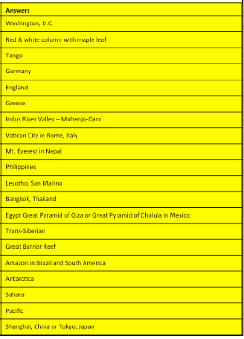
Map Skills Quiz Pt.1  Indiviudal activity.  - What horizontal lines show the distance north or south of the equator?  - Prime Meridian  - Tropics  - Latitude  - Longitude  - What vertical lines show distance east or west of the prime meridian?  - Prime Meridian  - Longitude  - Equator  - Tropic of Cancer  - What are the four main points of direction called?  - Cardinal directions  - Direction points  - Compass rose  - Ordinal directions | Map Skills Quiz Pt.2  - What are the in-between points of direction called?  - Cardinal directions  - Direction points  - Compass rose  - Ordinal directions  - What name is given to the portion of Earth located above the equator?  - Northern hemisphere  - Eastern hemisphere  - Western hemisphere  - Southern hemisphere  - What are the four main points of direction called?  - Northern hemisphere  - Eastern hemisphere  - Western hemisphere  - Southern hemisphere

Map Skills Quiz Pt.3  - What imaginary line divides the Earth into a northern half and a southern half?  - Prime Meridian  - Longitude  - Equator  - Tropic of Cancer  - What imaginary line represents zero degrees longitude?  - Prime Meridian  - Longitude  - Equator  - Tropic of Cancer  - What imaginary line marks the northern boundary of the tropics?  - Tropic of Capricorn  - Tropic of Cancer  - Tropic of Aquarius  - Tropic of Sagittarius | Map Skills Quiz Pt.4  - What imaginary line marks the southern boundary of the tropics?  - Tropic of Capricorn  - Tropic of Cancer  - Tropic of Aquarius  - Tropic of Sagittarius  - What instrument uses a needle to determine magnetic north on Earth?  - Sextant  - Chronometer  - Barometer  - Compass  - What circle, cut into degrees, show the orientation of directions on a map?  - Yellow cross  - Compass rose  - Scale  - Primary directions
Map Skills Quiz Pt.5  - What image, made by a cartographer, shows an area of land, sea or both?  - Chart  - Table  - Grid  - Map  - What part of a map explains the symbols that are used?  - Key  - Legend  - Key or legend  - Title  - What name is given to a scale model representation of the Earth?  - Tellurion  - Planetarium  - Globe  - Observatory | Map Skills Quiz Pt.6  - What is the name of the imaginary line around which the Earth spins?  - Axis  - Tilt  - Equator  - Angle  - What type of map shows landforms like mountains and deserts?  - Political map  - Physical map  - Resource map  - Climatic map  - What type of map shows governmental boundaries such as countries and cities?  - Political map  - Physical map  - Resource map  - Climatic map  (Map Skills Quiz Answer Key):  C, B, A, D, A, D, C, A, B, A, D, B, D, C, C, A, B, A

Types of Maps Pt.1  Topographic/Physical maps:  These maps show relief or height above sea level using contours. They also show physical features such as forests, rivers and lakes and cultural features such as roads, railways and settlements  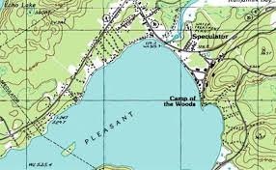  Choropleth maps:  A choropleth map is a map that uses colours/patterns to give specific information about demographics (population and people). The darker the colour shows the “most” of the feature.  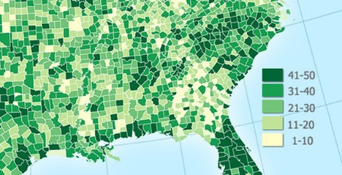 | Types of Maps Pt.2  Political maps:  These are maps which show different political regions in different colours and their borders. The most common political map is a world map showing countries/states.  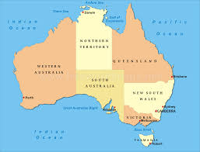  Sketch maps:  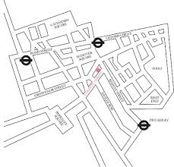  These are rough maps often drawn quickly to explain how to find a particular feature. These do not show correct scale.
Concept Mapping  Individual or partner activity. A concept map is like an extended brainstorm. They are a great way to practice your understandings or revise for tests. Begin with a topic we have studied in class. Write its name in the middle of your page. Around the name, write any major concepts that are related to the topic. Building out from the concepts, add in any key terms, dates, facts or personalities. You can also add another layer, providing definitions for terms, relevant examples etc. You can also use drawings or cartoons to help your understandings, or link various ideas together.  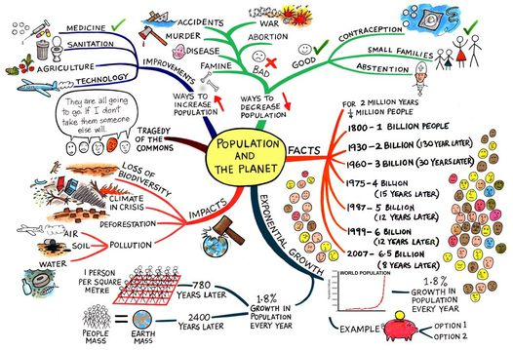 | Concept Hexagons  Partner activity. Cut up 8 hexagons each. Choose a topic we have studied in class e.g. Biomes. On each of your 8 hexagons, write down a different concept from that topic e.g. mangroves, sustainability, etc. With your partner, you then need to match all the hexagons into a grid-like formation based on how they are similar. Then you will film your hexagons and explain how each hexagon was connected to the next to reinforce your content knowledge.  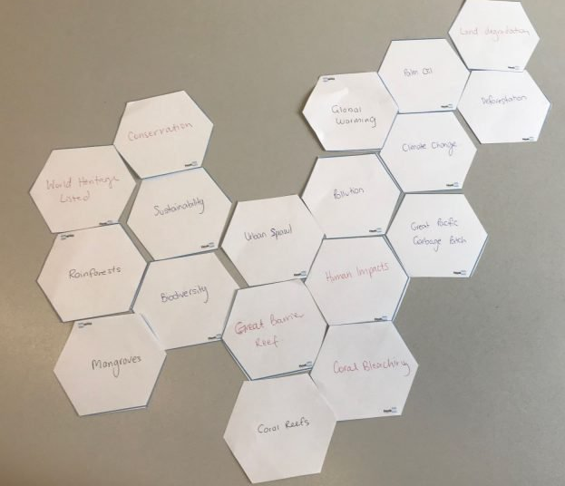

Mini Quiz Pt.1  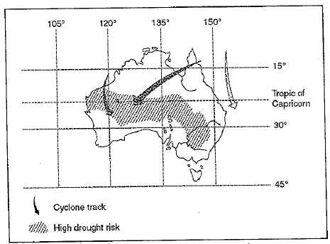  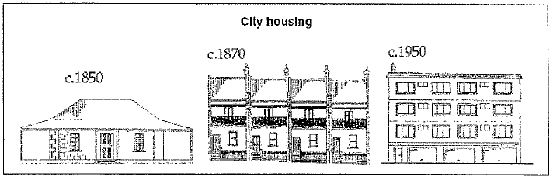  - Which of the following statements can be concluded from the source above?  - Melbourne is the city most at risk from tropical cyclones  - Brisbane is more likely to experience drought than Adelaide  - Sydney is more likely to experience a tropical cyclone than Perth  - Alice Springs is more likely to experience a drought than Darwin  a | Mini Quiz Pt.2  - In which latitudes does Australia have the highest drought risk (from source on previous card)?  - 20⁰S – 30⁰S  - 20⁰N – 30⁰N  - 110⁰W – 145⁰W  - 110⁰E – 145⁰E  A  - Using the source above, which geographical issue is best illustrated by the drawing?  - Air quality  - Land and water management  - Spatial inequality  - Urban growth and decline
Mini Quiz Pt.3  - What term best describes an individual Australia’s participation in community activities and public affairs?  - Citizenship  - Decision-making  - Heritage  - Sustainability  - The footpath of a local street is unsafe to use. How can individuals influence decision-making on this matter?  - Contact the Police  - Contact their Council Member  - Contact the Prime Minister  - Contact the Environmental Protection Agency  - Which of the following countries are part of the Asia-Pacific region?  - Egypt, Sri Lanka and Vietnam  - India, Indonesia and Samoa  - Cuba, East Timor and New Zealand  - Brazil, China and Papua New Guinea | Mini Quiz Pt.4  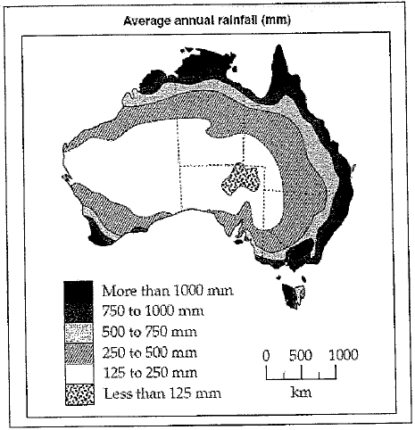  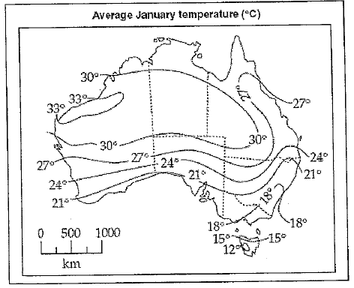

Mini Quiz Pt.5  Use the maps on the previous card to answer q. 7-9.  - Which Australian city experiences more than 1000mm of rainfall annallyand an average January temperature ofmore than 27⁰C.  - Perth  - Darwin  - Brisbane  - Adelaide  - Which is Australia’s driest state?  - Which Australian state averages the highest January temperatures?  A | Mini Quiz Pt.6  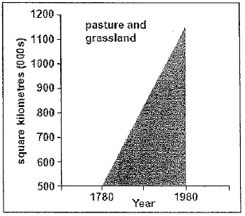  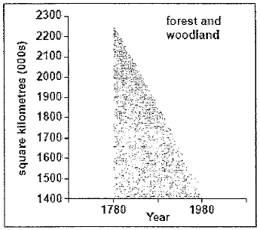  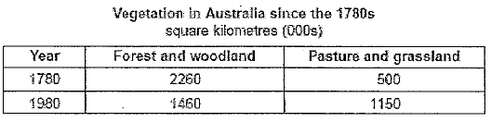
Mini Quiz Pt.7  Use the graphs on the previous card to answer q.10-12.  - How much of Australia was covered in pasture and grassland in 1880?  - 800 km²  - 1860 km²  - 800,000 km²  - 1,860,000 km²  - Calculate the percentage change in the area of forest and woodland between 1780 and 1980.  - 64.6%  - 35.4%  - 130.0%  - 54.7%  - Which of the following would most likely be the reason for these changes in vegatation patterns?  - Promotion of biodiversity  - Severe and widespread drought  - Extensive and frequent floods  - Expansion of agricultural land use | Mini Quiz Pt.8  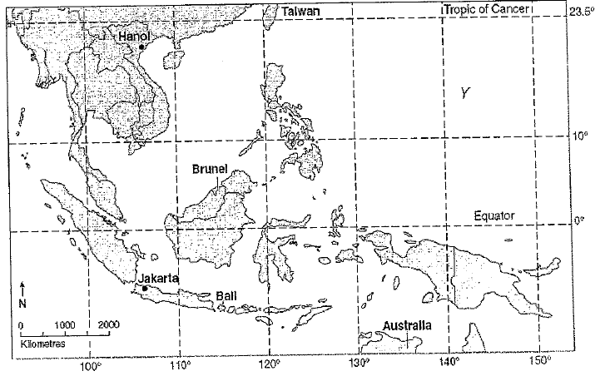

Mini Quiz Pt.9  Use the map on the previous card to answer q. 13-17.  - What is the name of the ocean located at Y?  - Arctic  - Indian  - Atlantic  - Pacific  - What is the direction of Taiwan from Jakarta?  - NNE  - SSW  - NE  - NNW  - Which of the following is a country in South-East Asia?  - Bali  - Brunei  - Hanoi  - Jakarta  A | Mini Quiz Pt.10  - The latitude and longitude of Hanoi is closest to:  - 21⁰S 106⁰E  - 21⁰N 106⁰E  - 21⁰N 106⁰W  - 106⁰N 21⁰E  - The bearing of Jakarta from Hanoi would be closest to:  - 0⁰  - 80⁰  - 180⁰  - 280⁰
Mini Quiz Pt.11  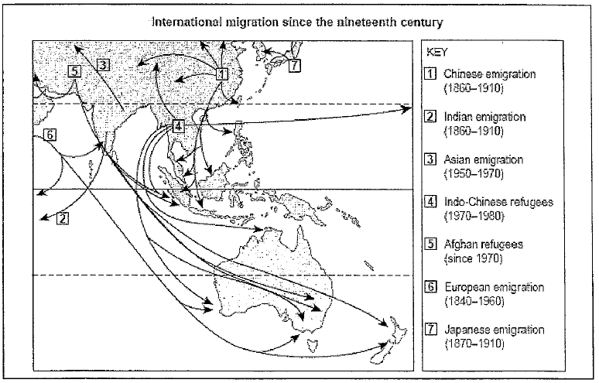 | Mini Quiz Pt.12  Use the map on the previous card to answer q. 18-20.  - From which region did Australia’s immigrants originate in the nineteenth century?  - Asia  - Europe  - China  - India  - Which statement best describes the flows of migrants to Australia in the twentieth century?  - Chinese and Indian people arrived  - Indian and Afghan people arrived  - Indo-Chinese and Afghan people arrived  - Japanese and Indo-Chinese people arrived  - Which of the following is an action that promotes social justice?  - Improving road infastructure  - Participating in a beach dune care group  - Re-introducing an endangered species to an area  - Establishing a remote health care facility for Indigenous Australians.

Mini Quiz Pt.13  Use this graph to answer q. 21-24.  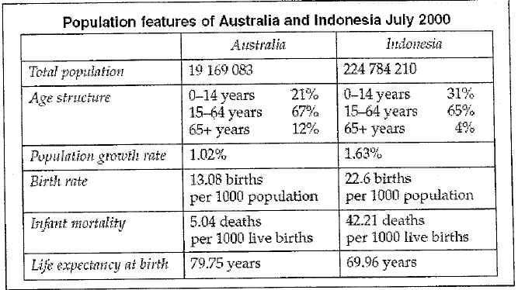  - What is Australia’s population as a percentage of Indonesia’s?  - 1.7%  - 8.5%  - 11.7%  - 85% | Mini Quiz Pt.14  - What reason could explain the difference in the proportion of 0-14 year olds in Australia and Indonesia?  - Indonesia has a higher life expectancy  - Australia has a higher life expectancy  - Australia has a higher birth rate  - Indonesia has a higher birth rate  - What reason could explain the higher proportion of Australians aged 65+?  - Indonesia has a higher life expectancy  - Australia has a higher life expectancy  - Australia has a higher birth rate  - Indonesia has a higher birth rate  - Which statement is incorrect?  - The age structure of the two countries is most similar in the 15-64 years section  - Indonesia’s birth rate is almost double that of Australia  - Indonesia’s IMR is 6 times that of Australia  - The population growth rates of the two countries are quite similar
Mini Quiz Pt.15  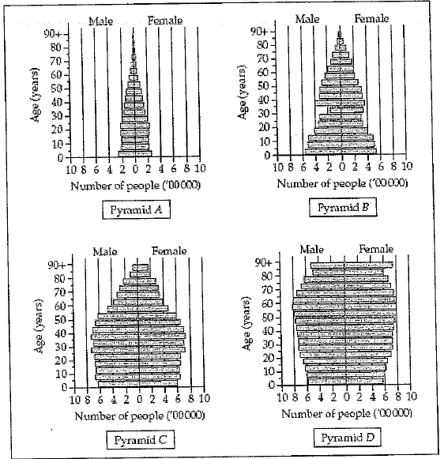 | Mini Quiz Pt.16  Use this graph on the previous card to answer q. 25-27.  - Which population pyramid best represents Australia’s current population structure?  - Pyramid A  - Pyramid B  - Pyramid C  - Pyramid D  - Which two population pyramids show an increasing birth rate in recent times?  - Pyramids A & B  - Pyramids B & C  - Pyramids C & D  - Pyramids A & D  - Which population pyramid shows the largest imbalance in the 30-35 age group?  - Pyramid A  - Pyramid B  - Pyramid C  - Pyramid D

Mini Quiz Pt.17  Use this graph to answer q. 28-31.  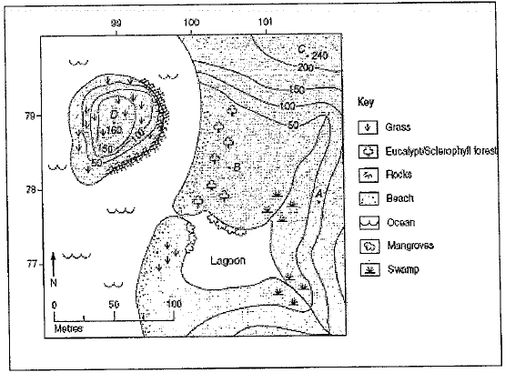  - What is the approximate relief between point B and point C?  - 30m  - 130m  - 230m  - 330m | Mini Quiz Pt.18  - What is the aspect of the slope at point A?  - North  - South  - East  - West  - What is the contour interval on the map above?  - 50m  - 100m  - 150m  - 200m  - What is the height of point C?  - 250m  - 200m  - 100m  - 240m  (Mini Quiz Answer Key):  D, A, D, A, B, C, C, South Australia, Western Australia, C, A, D, D, A, C, A, C, B, C, D, B, B, C, C, A, B, C, D, A, D
World Mapping Features Pt.2  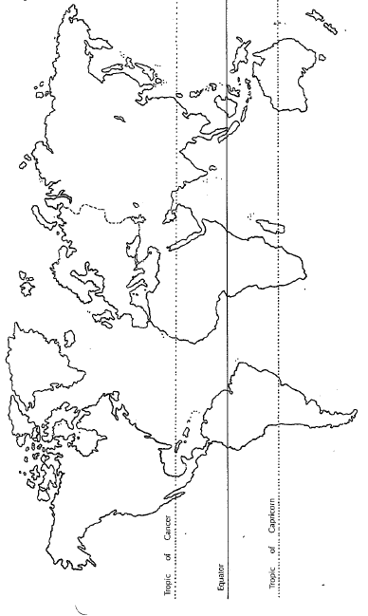  The Continents:  A continent is one of Earth’s seven main divisions of land and can be seen on the map below (excluding Antarctica).  Individual activity. Atlas activites to complete in your book:  - Name the 7 continents, in size order (largest to smallest).  - List 10 countries in the Southern Hemisphere (south of the Equator). | World Mapping Features Pt.3  Atlas Activites cont.:  - List 10 countries in the Northern Hemisphere (north of the Equator).  - List 4 islands or island groups in the Indian Ocean.  - List 4 islands or island groups in the Pacific Ocean.  - List 4 islands or island groups in the Atlantic Ocean.  - List 6 countries through which the Equator passes.  - List 6 countries through which the Tropic of Cancer passes.  - List 6 countries through which the Tropic of Capricorn passes.  - List 6 countries through which the Artic circle passes.

Stir the Pot – Geography Debating  Partner, group or whole class activity. Below are a number of topics that you can debate with a partner or small group. Choose one that interests you, pick a side and begin!  - Renewable forms of energy should be subsidised by the government.  - Australia should still provide foreign aid to countries that kill endangered animals.  - All people should be vegetarians in order to save the environment.  - The world should begin a process of population reduction to ease stress on the enviornment.  - People should be fined for not recycling.  - The United Nations should intervene to reduce child marriage and rape.  - Every household should have a drone for day-to-day unrestricted use to ensure we are all connected.  - All Australian teachers should be made to work in a developing country for at least one year to help improve literacy rates (ability to read and write).  - The number of overseas trips you take each year should be restricted to reduce pollution. | Write a Report like a Pro  Individual activity. A lot of Geography requires you to be able to write reports. Reports are different to essays or other extended responses, as they are more factual, often use sub-headings, and don’t require as much persuasive writing. Check out the report checklist to help improve your writing…  Choose a geography topic you are interested in (it doesn’t have to be something we have studied in class). Conduct some internet research into your topic, then write a (minimum) one-page report, following the checklist above, that could be given to another student to teach them about the topic.

